**algacom AG**

**aMIRA – Management of Identities, Resources and Access**

ations

**aMIRA Concepts Guide**

Version 2.5

**I – Table of Contents**

1 Introduction 5

1.1 aMIRA Modules 5

1.1.1 Identity and Account Management 5

1.1.2 Resource and Access Management 5

1.1.3 Provisioning 6

1.2 Typical System Architecture and Landscape 7

1.3 Data Model Basics 8

1.3.1 Entities and Types 8

1.3.2 Property Bags 8

1.3.3 Ownership, Dependencies and Relations 9

1.4 System Components and Deployment Options 9

1.4.1 On-Premises Deployments 10

1.4.2 Deployments in Cloud Scenarios 10

2 Data Management Models 11

2.1 Manual Data Management 11

2.2 Externally Driven Data Management 11

2.3 Policy Based Data Management 12

2.4 Mixed Data Management 12

3 Persons, Accounts and Personal Network Resources 14

3.1 Data Model 14

3.1.1 Definition 14

3.1.2 Default Types 15

3.2 Object Status and Lifecycle 15

3.2.1 Status Values 15

3.2.2 Status Value Dependencies 17

3.2.3 Automatic Status Transitions 17

3.3 Default Lifecycle 18

3.3.1 Persons 20

3.3.2 Accounts and Personal Network Resources 22

3.4 Business Processes and Use Cases 24

3.4.1 New Hires 24

3.4.2 Updates 24

3.4.3 Transfers 25

3.4.4 Temporary Leaves 25

3.4.5 Re-Attestation 26

3.4.6 Terminations 26

3.4.7 Re-Hires 26

3.4.8 Archiving 27

3.5 Helpdesk Functions 27

3.5.1 Password Reset 27

3.5.2 Account Unlock 28

4 Resources and Access 29

4.1 Data Model 29

4.1.1 Definition 29

4.1.2 Default Types 30

4.2 Object Status and Lifecycle 30

4.2.1 Status Values 30

4.2.2 Status Value Dependencies 31

4.2.3 Automatic Status Transitions 32

4.3 Default Lifecycle 32

4.3.1 Shared Resources 33

4.3.2 Accesses 35

4.4 Business Processes and Use Cases 37

4.4.1 Resource Creation 37

4.4.2 Access Management 37

4.4.3 Access Request and Approval Workflows 38

4.4.4 Resource and Access Re-Attestation 40

4.4.5 Escalations 40

4.4.6 Resource Decommissioning 40

5 Collections 41

5.1 Data Model 41

5.1.1 Definition 41

5.1.2 Default Types 42

5.2 Object Status and Lifecycle 42

5.3 Default Lifecycle 42

5.4 Business Processes and Use Cases 43

5.4.1 Organizations 43

5.4.2 Access Role Profile 44

5.4.3 Non-Personal Objects 45

5.4.4 External Institutions and Service Providers 45

5.4.5 Simplified Resource Management 46

5.4.6 Complex IT Services 47

5.4.7 Putting it all together 49

6 Business Policies Validation and Automation 50

6.1 Model 50

6.1.1 Triggers 51

6.1.2 Policy Actions 51

6.1.3 Effects 51

6.2 Business Processes and Use Cases 51

6.2.1 Business Role Assignments 51

6.2.2 Organizational Affiliations 51

6.2.3 Access Attestation for Movers 51

6.2.4 Data Maintenance and Provisioning Automation 52

7 Security Model 53

7.1 Authentication Model 53

7.2 Authorization Model 53

7.3 Default Role Model 54

8 User Interfaces 55

8.1 Graphical User Interface 55

8.2 Web Services API 55

9 Inbound Interfaces 56

9.1 Structural/Lookup Data Feeds 56

9.2 HR Feeds 56

9.2.1 Interface Implementation 57

9.2.2 HR-Driven Person Status Transitions 57

9.3 Target System Backfeeds 59

10 Outbound Interfaces 60

10.1 Provisioning 60

10.1.1 Architecture of aMIRA Provisioning 60

10.1.2 Target Systems Supported by aMIRA Provisioning 62

10.2 Notifications 63

10.3 Reporting 63

11 Glossary and Abbreviations 64

# Introduction

**aMIRA** – **a**lgacom **M**anagement of **I**dentities, **R**esources and **A**ccesses – is algacom's software product offering for identity and access management (IAM). It provides a comprehensive, efficient and user-friendly solution to implement standardized and compliant user and resource lifecycle management services in medium to large enterprises.

## aMIRA Modules

aMIRA consists of three main modules:

* Identity and Account Management
* Resource and Access Management
* Provisioning

Although these three modules work perfectly in combination, they can be deployed and used separately – thus adapting perfectly to a customer's needs.

### Identity and Account Management

Identity and account management denotes the classical user management discipline, i.e. managing the persons working in and for an organization. Essentially, this means managing the whole lifecycle of employees, external contractors or service providers as they join an organization, go through several changes (e.g. international transfers, organizational changes, …) and finally leave the company.

Quite typically, identity and account management integrates with HR (human resources) to benefit from data that is already available in the company.

Identity and account management also encompasses the management of accounts and resources that are personal – and therefore strictly bound – to the individuals. Examples for such objects are basic network accounts (e.g. Active Directory), personal mailboxes (e.g. Office 365, Google Mail, …), or personal accounts to business applications. These accounts and personal resources cannot exist without the person that they represent. In other words, when the person leaves the company, also these accounts and personal resources must be deleted.

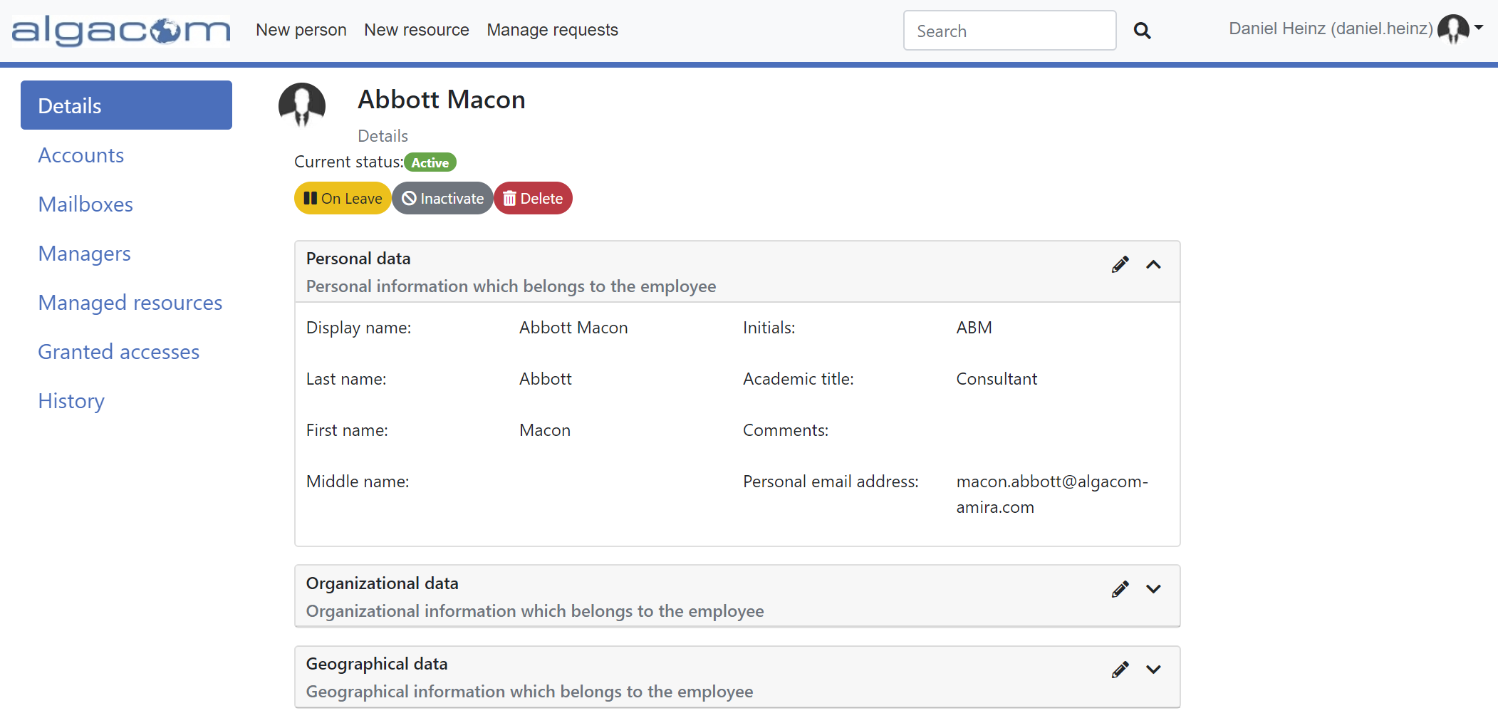

### Resource and Access Management

Resource and access management deals with the lifecycle of network resources shared among multiple users. Although being associated with specific persons throughout their lifetime (e.g. the owner of a resource), they are not tightly bound to the lifecycle of these persons. In other words, when the owner of a resource leaves the company, the resource continues to exist – although as an "orphaned" resource that needs to be associated with another person as the new owner.

Resource and access management also controls who has, had or will have access to the resources.

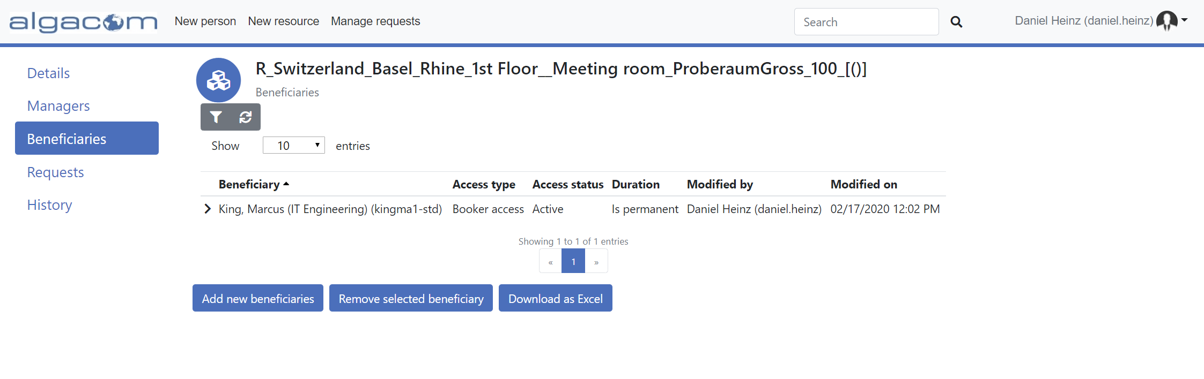

### Provisioning

Provisioning is the process of propagating changes from aMIRA to the target systems and services that are integrated and hence controlled through aMIRA. For example, this includes the creation of accounts, modifying properties of a mailbox, granting or revoking access to a resource, or deleting resources that are no longer required.

Provisioning provides a number of standard connectors out-of-the-box (e.g. Active Directory, Office 365, …). Additional – also custom – systems can be easily integrated through its open and extensible architecture.



## Typical System Architecture and Landscape

aMIRA lives best in a typical Microsoft environment. It runs on Windows Server and utilizes Active Directory for authentication and authorization purposes. Moreover, it uses SQL Server as its data store.

However, in terms of supported target systems, aMIRA is very open and highly extensible. Systems that are not supported out-of-the-box can easily be integrated (e.g. using web services).

The following diagram shows a typical system architecture:



The diagram illustrates several important points:

* Ideally, identity and account management should make use of HR systems as main data providers to support the lifecycle of person data in the organization.
* Identity and account management as well as resource and access management can both possibly benefit from other metadata sources to automate the management of structural data (e.g. the geographical and organizational model of the company, list of cost center codes from finance, …).
* The aMIRA web UIs expose data management capabilities that are used by supporting organizations (e.g. registration desks, service desk, …) as well as for self-service enabling of end users.
* Provisioning propagates data changes to the connected systems within the organization's own network as well as to cloud services
* aMIRA can integrate with cloud-services for process automation – e.g. to respond to request tickets or to exchange infrastructure data with CMDBs.
* All functionalities exposed by aMIRA through the web UI are also available via RESTful APIs for automation and scripting purposes.

## Data Model Basics

The different types of objects that are managed using aMIRA will be described in detail in the appropriate chapters of this document. The following are a few basic terms and concepts that apply to the aMIRA data model in general.

### Entities and Types

aMIRA is generally used to manage the following **entities**:

* **Persons** – individuals working in or for an organization
* **Accounts** – essentially credentials in connected target systems
* (Network) **Resources** – personal or shared resources in connected target systems
* **Collections** – logical grouping of managed entities

All these entities can be configured according to the customer's needs by defining **types**, e.g.:

* Persons: employees, external collaborators, service providers, …
* Accounts: AD accounts, AD admin accounts, SAP accounts, …
* Resources: Exchange user mailboxes, Exchange shared mailboxes, file shares, …
* Collections: organizations, IT services, service providers, …

These type definitions include:

* **Properties** – the data fields to be managed/stored (e.g. firstname, lastname, email address, …). These are configured and managed using so called property bags – see below
* **Relations** – the "links" between managed entities (e.g. manager, owner, …)

All entities managed by aMIRA have a common set of properties:

* Status
* Display Name (for displaying the entity on the graphical UI)
* Property bags – see below
* Relations (the ones that are not in the PB)

Note: additional properties may exist for certain entities.

### Property Bags

A **property bag** is essentially a set of properties managed for an entity. It is based on a **property bag type** definition that supports the following capabilities:

* Properties – name, data type, initial/default values
* Validation – for individual properties as well as for the whole property bag
* Uniqueness – rules for uniqueness checks
* Labels – including localization

Property bags can be **grouped** to further structure the information managed in aMIRA. For example, employees may have three property bags:

* Personal data
* Organizational data
* Geographical data

### Ownership, Dependencies and Relations

aMIRA distinguishes several ways how objects can be "linked" together:

* **Ownership** denotes the situation where a subordinate entity is owned by a superior entity, e.g.:
  + A personal account is owned by a person
  + A personal mailbox is owned by a person
  + A shared resource is owned by a person – see note below
* **Dependency** denotes a "technical link" between entities, e.g.:
  + An Exchange mailbox depends on an AD account
  + A home directory depends on an AD account
* **Other Relations** are additional – configurable – links between entities. These can be inside (=implicit) or outside (=explicit) of a property bag, e.g.:
  + Person A is the manager of person B
  + Employee C is the internal contact person for supplier D

Note: in scenarios where aMIRA does not manage persons and accounts (i.e. for customers only utilizing the resource and access management functionalities), ownership of a resource would be an external account (usually an AD account in the target system).

By default, only ownership and dependency have an effect in aMIRA, e.g.:

* Registration: registering an Exchange mailbox requires indicating an AD account it will depend on
* Status propagation: deleting an account will also delete all resources that depend on it (mailbox, home directory, …)

## System Components and Deployment Options

The aMIRA system consists of several components that interact via a service bus. All components utilize the SQL Server database for data persistence.



aMIRA can be deployed on-premises or utilizing cloud services (such as Azure).

### On-Premises Deployments

In its original form, the aMIRA system is based on the Windows OS and consists of a web application hosted by IIS and several Windows services. Data is stored in a SQL Server database.

As such, aMIRA can be deployed on a single Windows server and use either a dedicated or a shared SQL Server database.

### Deployments in Cloud Scenarios

aMIRA can also be implemented in cloud scenarios – making use of cloud-based infrastructure for servers and databases.

# Data Management Models

aMIRA – as IAM in general – is all about a controlled and auditable management of data. aMIRA supports three basic models:

* Manual data management
* Externally driven data management
* Policy driven data management

To a certain extent, the models can also be combined, resulting in a mixed data management model.

## Manual Data Management

Manual data management essentially means using the aMIRA web UI to create and maintain records. Depending on the type of objects, companies may choose to task specialized organizations for this purpose (i.e. admin-driven maintenance by e.g. HR, ServiceDesk, …) or even delegate this out to the end users (i.e. self-services).

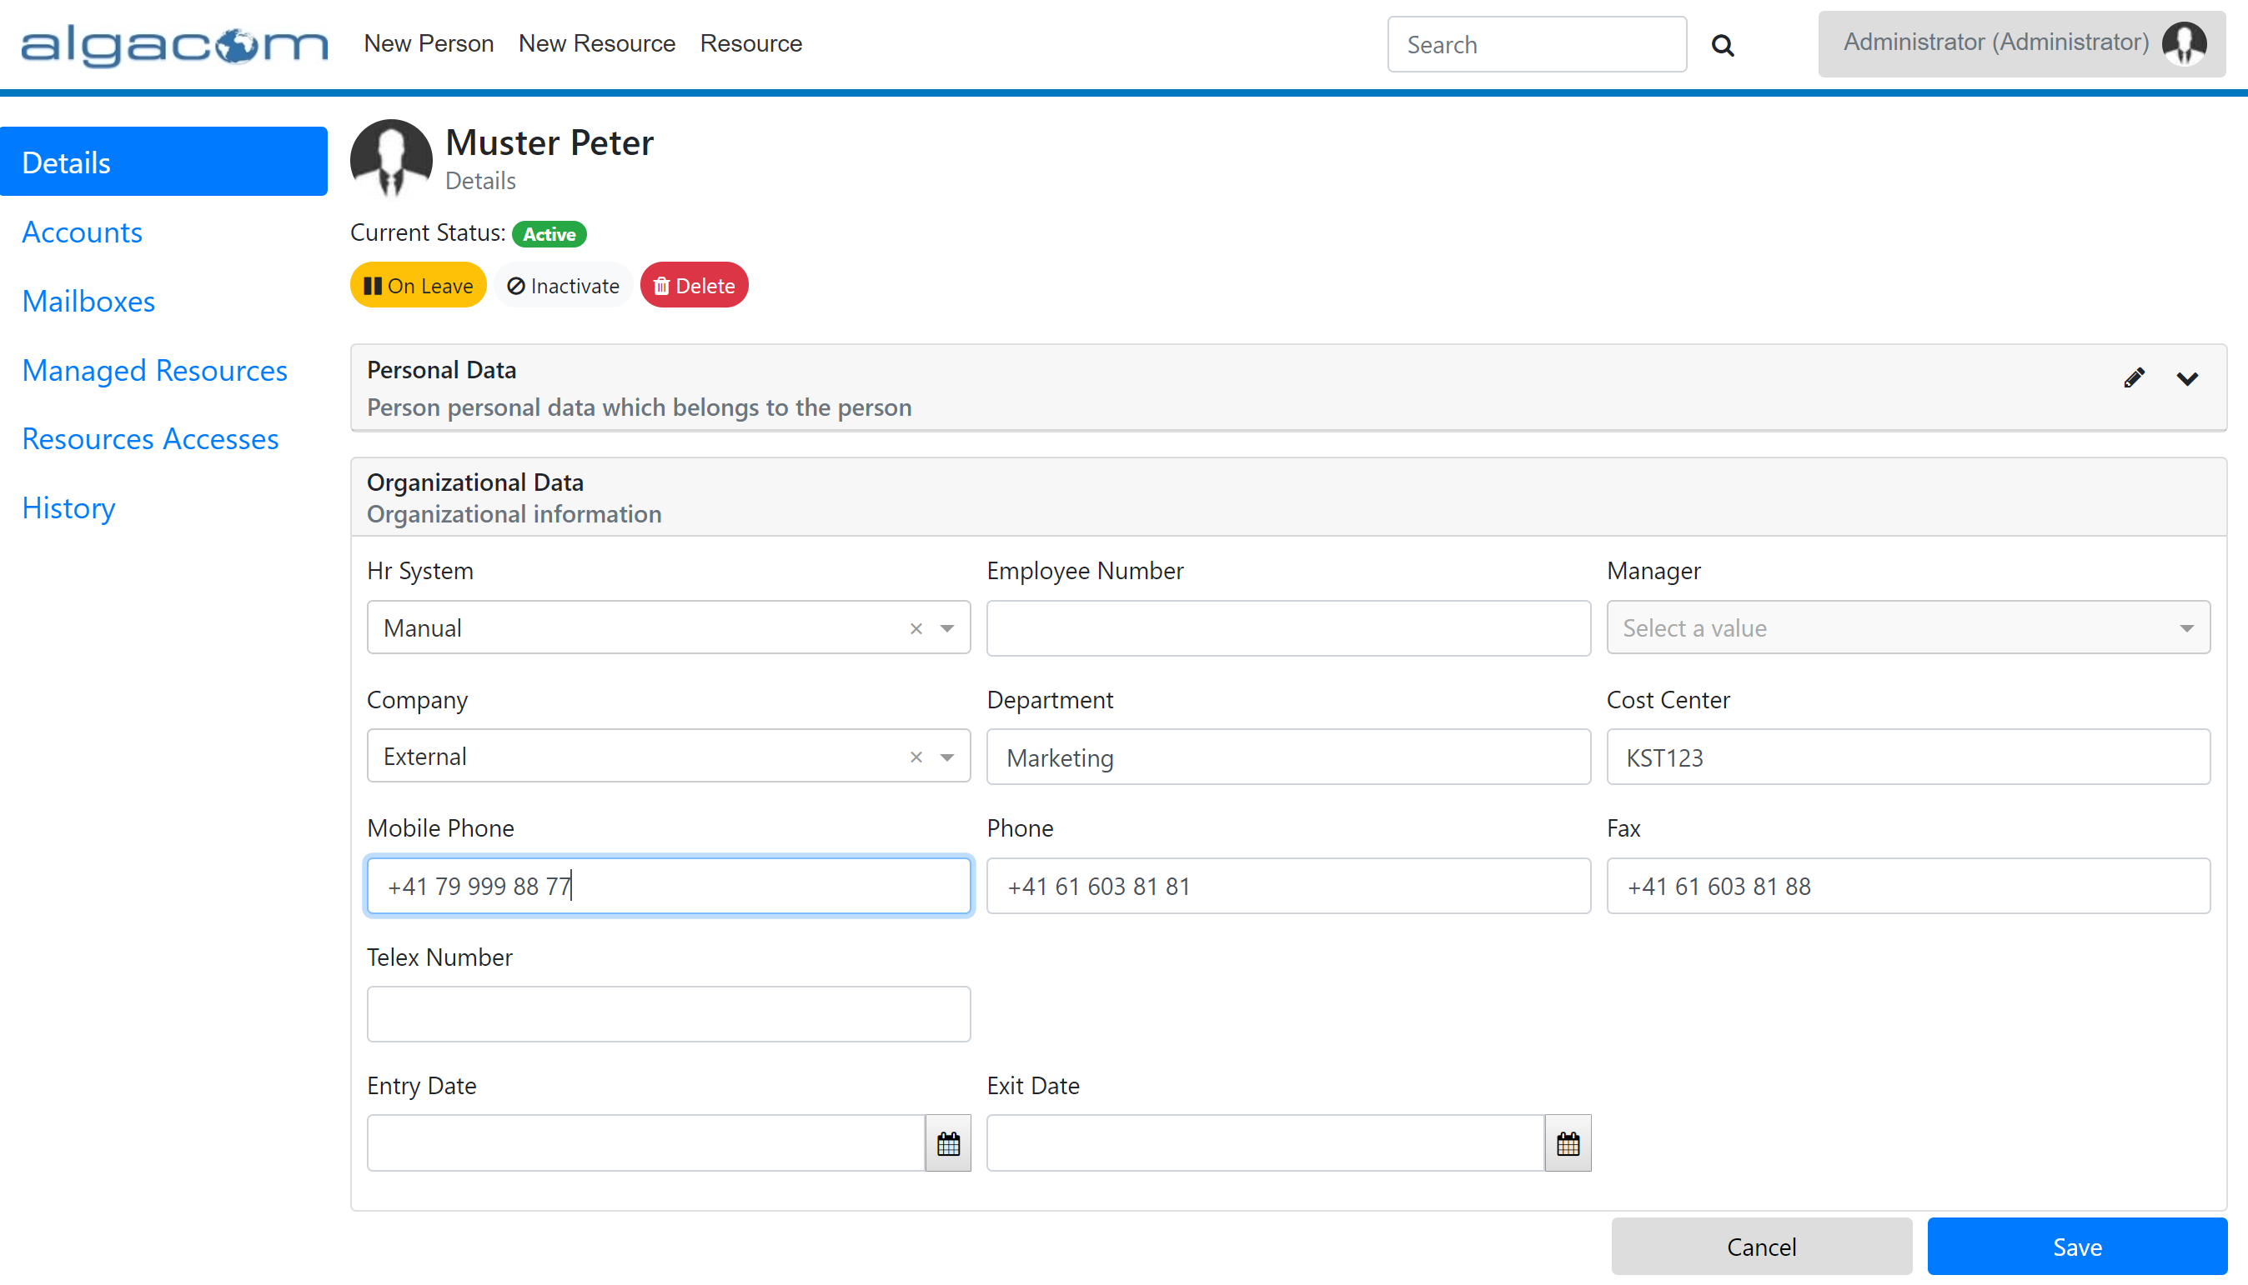

The possibilities of manually maintaining objects in aMIRA is defined through the authorization model, which determines which objects and object properties can be created or edited by the logged-on user.

## Externally Driven Data Management

Externally driven data management involves the integration of aMIRA with authoritative external data sources.

The most common example for this model is the integration with human resources (HR) databases: a technical interface enables the data flow between HR and aMIRA allowing HR to drive the creation of new person objects as well as the ongoing maintenance and final termination of existing person objects.



As HR takes ownership of these person objects in aMIRA, the objects are said to be "HR-linked" and their data fields are blocked from being edited manually in aMIRA.

Note that the external data source may not be providing all data elements maintained for an object. In this case, other models will apply for data elements not in the scope of the data source.

aMIRA provides two mechanisms for the integration of data sources:

* Feeder process most suitable for HR integration
* Web services API for general automation purposes

The feeder process usually operates on a full data extract from a data source and processes all required changes into the data in aMIRA, i.e. all affected objects in aMIRA are updated "at once". Instead, the web services API allows operations on individual objects.

## Policy Based Data Management

Policies refer to a level of automation within aMIRA – essentially driving the creation and maintenance of data through e.g.

* events – e.g.: newly hired employees must automatically be provided with an AD account and an Office 365 mailbox
* other data elements – e.g.: the AD account's displayName is automatically constructed by concatenating the person's lastname and firstname
* rules – e.g.: the AD account's userID must automatically be made unique by the system

The keyword in all these examples is "automatically". This can involve individual data elements (such as the displayName of an account) or complete objects (such as an AD account).

aMIRA offers capabilities to map the business model into the required automation. These is described in more detail in chapter 6.

## Mixed Data Management

In most cases, a mix of models will be applied in a real-life aMIRA implementation. Here is an example on how this could look like:

1. **Externally driven**: HR is driving the creation and ongoing maintenance of person objects. The feeder between HR and aMIRA transports HR-managed data – including (among many others) the lastname, firstname and the department of the person.
2. **Manual maintenance, admin-driven**: aMIRA doesn't allow editing the firstname, lastname and department in the Web UI, as these three fields are owned by HR. However, it allows editing the phone and fax numbers; and explicitly grants this right to the telephony team
3. **Manual maintenance, self-service driven**: Maintenance of the building/room information is being delegated to the end users themselves, i.e. every user has the permission to edit his/her own person object, but change only the building/room field.
4. **Policy based**: the company wants to give all new hires an account and a mailbox; so, these objects are created automatically whenever the HR feeder creates a new person object. No need for manual intervention.
5. **Policy based**: since accounts and mailboxes need unique identifiers (userID and email-address), aMIRA automatically creates unique and compliant (naming conventions!) values based on the person's firstname and lastname. Again, no need for manual intervention.

This example is illustrated in the following diagram:



# Persons, Accounts and Personal Network Resources

## Data Model

### Definition

**Persons** are the principal objects managed in the aMIRA identity and account management module. In fact, persons are the only type of identities known to aMIRA – and aMIRA allows to differentiate subtypes as granular as needed by the business model (e.g. employees, external contractors, service providers, and so on).

aMIRA supports non-personal objects (some IAM system call these "generic identities") in the form of resources or collections – see chapters 4 and 5.

Persons can own any number of **accounts** and **personal network resources** – depending on the defined business model. For example, a person could have several AD accounts (a standard account with a home directory on a file server, a test account and a privileged admin account), an Office 365 mailbox associated with the standard account and finally a Google account used for collaboration.

aMIRA differentiates between accounts and personal network resources (PNRs):

* Accounts are essentially credentials that are – ideally – only known to the person they belong to. You cannot manage access to an account, i.e. the only way to grant someone else access to an account is to share the credentials.
* Personal network resources are real resources in the sense that someone else can be granted access to them through their own credentials, i.e. an assistant can be granted access to a manager's mailbox through the assistant's own mailbox – thus effectively providing access management.

The following diagram illustrates the data model – and particularly also the difference between accounts and PNRs:



In this example, person 1 – the assistant – owns three accounts. One of these (the standard account) has a home directory and an Exchange mailbox. Additionally, the assistant owns a Google mailbox. Person 2 – the manager – has a single account with a home directory and a mailbox. Moreover, the assistant can access the manager's mailbox through his/her own mailbox – without having access to the manager's account (i.e. credentials). Moreover, the two persons are linked by a relation denoting that person 2 is the manager of person 1.

### Default Types

Type configurations can be used to tailor the persons, accounts and resources managed in aMIRA to the actual needs of the company. aMIRA provides several default types out of the box, which can be used as a starting point.

The defaults cover scenarios like:

* Employees
* External collaborators
* Service providers
* Partners
* …

## Object Status and Lifecycle

Objects managed in aMIRA have a defined status. For example, a person with a valid contract and thus working for the company is in status "active" whereas a person who has left the company is usually in status "inactive".

Moreover, the status of objects that are related to each other may also be dependent. In fact, accounts and PNRs associated with an inactive person cannot be active.

Finally, status transitions of one object may trigger automatic status transition of other objects, i.e. a person leaving the company must have all accounts and PNRs deleted automatically.

### Status Values

#### Persons

The default status values for **persons** are as follows:



Definition:

* **Active**: the person is actively working for the company (i.e. active/valid working relation or contract)
* **On Leave**: the person has an active working relation/contract, but is currently not working for the company (e.g. sabbatical, maternity leave, …)
* **Inactive**: the working relation/contract has been terminated and the person is no longer working for the company
* **Deleted**: essentially, the same as "inactive", but used by aMIRA to hide data (i.e. person objects in this status are not shown in the search results by default)
* **Purged**: the data does no longer need to be managed/tracked by aMIRA (i.e. it is not needed anymore)

As shown in the diagram, only the "Purged" status is a terminal status. Transitions between the four other status values are possible in all directions. This allows modeling common business use cases such as:

* A person on leave resumes working after the maternity leave
* A person who used to work for a company is re-hired after having been inactive for several years
* A person's contract is terminated

The "Purged" status is used to dispose of person objects that aMIRA shall no longer actively manage. If desired or required, these objects could then effectively be removed from the database. Typical scenarios could be as follows:

* Removal of person data after a legal retention time
* Removal of person data that has been created by mistake (e.g. duplicates) or for testing purposes
* Data that is ready for being moved to an archive

Note: the defined status values, transitions and semantics are the defaults that aMIRA provides. Customers can choose to give the statuses different semantics or not to use all the statuses and transitions.

#### Accounts and PNRs

The default status values of **accounts** and **PNRs** are:



Definition:

* **Enabled**: the object is actively in use
* **Disabled**: the object is still needed and fully in place, but it cannot be used or accessed. The effect of this status depends heavily on the actual target system, e.g. an AD account will be disabled, an Exchange mailbox will be hidden and "sealed" (i.e. access denied, send-to denied). Other implementations are possible according to customer requirements.
* **Deleted**: the object is no longer needed and can therefore be disposed of; when entering this status, a timer is set to control delayed disposal – thus giving a "grace period" to recover from accidental deletions
* **Purged**: the object's disposal grace period is over and hence the object can effectively be removed from the target environment. Recovery is no longer possible. Although the object remains in aMIRA, it is no longer tracked/managed.

aMIRA itself is target system agnostic and therefore provides a two-step deletion process with a grace period in which a deleted object can usually be recovered without loss of data and/or functionality.

Depending on the capabilities of the actual target system, this may or may not be possible – or offer additional possibilities, that would then require some alignment within the model used in aMIRA (e.g. soft delete and recycle bin available in newer versions of Active Directory).

Important: a deleted object can only be recovered (e.g. changed back to enabled) *without* any data and/or functionality loss *during* the grace period. Once the grace period is over, the object's status is aMIRA changes to "Purged" and the object is removed from the target environment (e.g. Active Directory, Office 365, …).

### Status Value Dependencies

#### Between Persons and Accounts/PNRs

All personal objects owned by a person (e.g. accounts, mailboxes, …) must follow the lifecycle of "their" person. Essentially, the status of the person restricts the possible status values of accounts and PNRs associated with that person.

This is summarized in the following table:

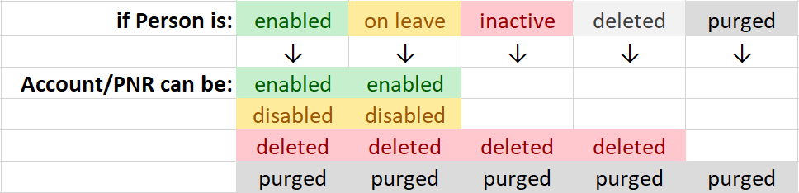

Example: if the person is "inactive", the only possible status value for accounts and PNRs owned by the person is "deleted".

#### Between Accounts and PNRs

Similar mechanisms also exist between accounts and PNRs, if the PNRs depend on accounts (i.e. are technically associated with accounts). Typical examples would be:

* A home directory associated with an AD account
* An on-premises Exchange mailbox associated with an AD account

This is summarized in the following table:

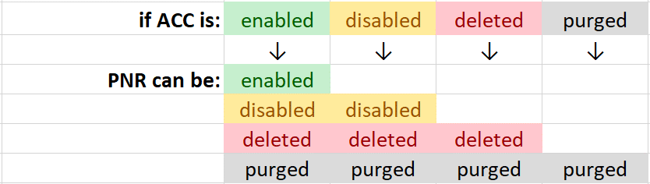

Example: if the account is "disabled", the only possible status values for the PNR that depends on the account are "disabled" and "deleted".

### Automatic Status Transitions

#### On Person Status Changes

Changes of the status value of a person may automatically trigger changes to the status of that person's accounts and PNRs. The most common example: when a person leaves the company (and therefore the person's status changes to "inactive"), the status of all the personal objects must forcedly change to "deleted".

The following table shows how the person status "drives" the status of accounts and PNRs:

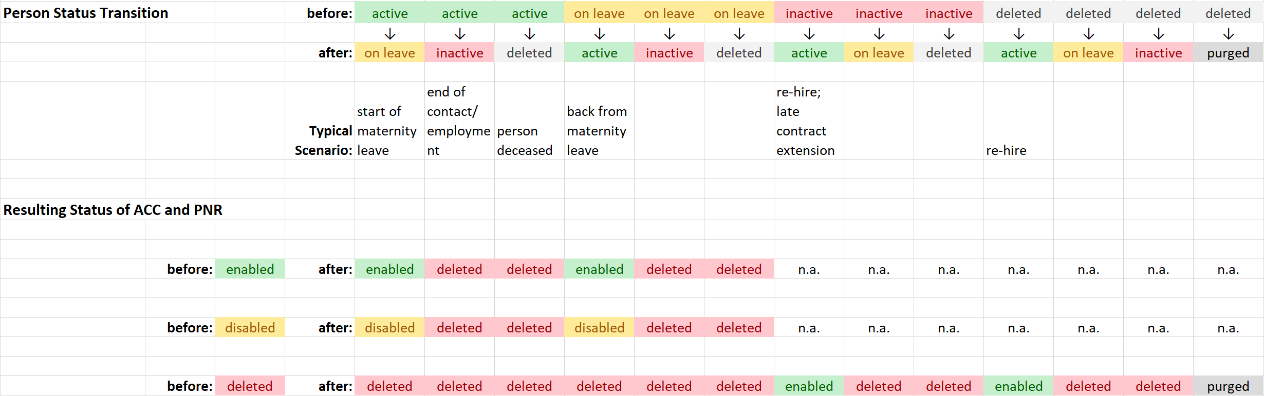

Example: a person's status changes from "active" to "inactive". As a result, the status of accounts and PNRs of that person must change as follows:

* If the former status is "enabled", the new status will be "deleted"
* If the former status is "disabled", the new status will be "deleted"
* If the former status is "deleted", the status will remain "deleted"

#### On Account Status Changes

Changing the status of an individual account may have an impact on the status of the PNR(s) that are technically dependent to that account (e.g. Exchange mailbox connected to an AD account).

This is summarized in the following table:

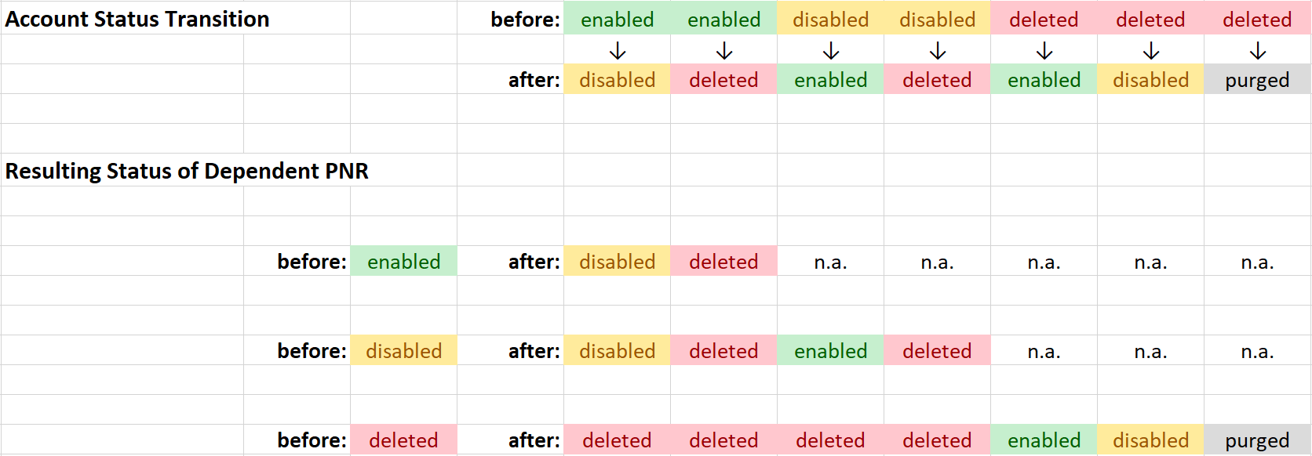

Example: the status of an account changes from "disabled" to "enabled". The status of the connected PNRs changes as follows:

* If the former status is "disabled", the new status will be "enabled"
* If the former status is "deleted", the status will remain "deleted"

Note: the PNR's status cannot be "enabled", since this is not allowed in conjunction with a non-enabled account.

## Default Lifecycle

aMIRA provides a predefined lifecycle for managing persons and accounts/PNRs. The following actors and roles are involved:

|  |  |  |
| --- | --- | --- |
| **ID** | **Definition of Actor or Role** | **Examples** |
| REQ | Requestor – user submitting/initiating a request | * Line manager requesting a person object for a contractor * Assistant requesting access to a manager's mailbox |
| OTO | Object Type Owner – user(s) responsible for approving requests for new objects according to the selected workflow for such requests. | * HR to approve new person object requests * IT to approve new test account requests |
| PMG | Person Manager – user set as manager of a person | * Functional or company manager of a person |
| RMG   * OWN * DEP * ESC | Resource Manager – user responsible for managing individual resources  aMIRA differentiates between   * Owner * Deputy * Escalation contact | * Owner of a shared mailbox who manages access * Deputy of the owner of a file share who can approve access requests * Escalation contact who is forwarded access requests that are not processed in time |
| BEN | Beneficiary – user being granted access to a resource | * Project team member having access to a document library * User being member of a distribution list |
| SLF | Person him/herself | * Person on his/her own record |
| USR | User – any authenticated user (no particular role) | * Anybody who successfully authenticated to the system |
| DSK | ServiceDesk – user with IT support responsibilities | * Service Desk agent * Helpdesk personnel |
| ADM | Administrator – user with system management privileges | * aMIRA administrator |
| INT | Interfaces – technical interfaces feeding into the system | * HR feeds * Metadata feeds |

These definitions are independent of how an event is triggered, e.g. interactively via Web UI, programmatically via web services API, …

### Persons

The following table defines the default behavior of aMIRA. The lifecycle can be adapted to specific needs.

| **ID** | **Lifecycle Event** | **Trigger** | **Definition** | **Provisioning and Notifications** | **Cascading / Other Events** |
| --- | --- | --- | --- | --- | --- |
| P1 | Person Requested | actor | A new person object has been requested | Notify OTO |  |
| P2 | Person Request 1st Reminder | time | Request has been pending for 2 days (configurable) | Notify OTO and REQ |  |
| P3 | Person Request 2nd Reminder (Escalation) | time | Request has been pending for 5 days (configurable) | Notify DSK and REQ |  |
| P4 | Person Request Commented | actor | A comment has been added to a request | Notify REQ and OTO  Notify DSK (if already escalated) |  |
| P5 | Person Request Approved | actor | A request for a new person has been approved | Notify REQ  Notify DSK (if already escalated) | Triggers P8 |
| P6 | Person Request Rejected | actor | A request for a new person has been rejected | Notify REQ  Notify DSK (if already escalated) |  |
| P7 | Person Request Cancelled | actor | A request for a new person has been cancelled | Notify OTO  Notify DSK (if already escalated) |  |
| P8 | Person Registered | actor  INT, P5 | A new person object has been registered | Notify PMG (if set)  Provision new target system object (if applicable) |  |
| P9 | Person Data Changed | actor  INT | Data for an existing person object has been changed (except status and manager) | Provision changes to target system object |  |
| P10 | Person Manager Changed | actor  INT | Manager for an existing person object has been changed | Notify old and new PMG |  |
| P11 | Person who is a Manager Changes Status A->Anything Else  (i.e. no longer active) | n.a. | Person who is a manager change status from active to something else. | Notify DSK |  |
| P12 | Person Move | actor  INT | Person is moved organizationally and/or geographically | Notify PMG | Triggers P26  Triggers X14 (see 4.3.2) |
| P13 | Person Status A→L | actor  INT | Person's status changed from active to on-leave | None |  |
| P14 | Person Status A→I | actor  INT | Person's status changed from active to inactive (explicitly or because Exit-Date is reached) | Notify PMG  Optional: pre-notify PMG 5 days prior to this event (based on Exit-Date, configurable) | Cascade status change to person's accounts and PNRs |
| P15 | Person Status A→D | actor  INT | Person's status changed from active to deleted | Notify PMG | Cascade status change to person's accounts and PNRs |
| P16 | Person Status L→A | actor  INT | Person's status changed from on-leave to active | None |  |
| P17 | Person Status L→I | actor  INT  time | Person's status changed from on-leave to inactive (explicitly or because Exit-Date is reached) | Notify PMG  Optional: pre-notify PMG 5 days prior to this event (based on Exit-Date, configurable) | Cascade status change to person's accounts and PNRs |
| P18 | Person Status L→D | actor  INT | Person's status changed from on-leave to deleted | Notify PMG | Cascade status change to person's accounts and PNRs |
| P19 | Person Status I→A | actor  INT | Person's status changed from inactive to active | Notify PMG | Cascade status change to person's accounts and PNRs |
| P20 | Person Status I→L | actor  INT | Person's status changed from inactive to on-leave | Notify PMG | Cascade status change to person's accounts and PNRs |
| P21 | Person Status I→D | actor  INT | Person's status changed from inactive to deleted | Notify PMG |  |
| P22 | Person Status D→A | actor  INT | Person's status changed from deleted to active | Notify PMG | Cascade status change to person's accounts and PNRs |
| P23 | Person Status D→L | actor  INT | Person's status changed from deleted to on-leave | Notify PMG | Cascade status change to person's accounts and PNRs |
| P24 | Person Status D→I | actor  INT | Person's status changed from deleted to inactive | Notify PMG |  |
| P25 | Person Status D→P | actor  INT | Person's status changed from deleted to purged | None | Cascade status change to person's accounts and PNRs |
| P26 | Person Attestation Started | actor  INT  time | Request for attestation of person has been started | Notify SLF and PMG |  |
| P27 | Person Attestation 1st Reminder | time | Person attestation request has been pending for 30 days (configurable) | Notify SLF and PMG  Notify "initiator" (if not INT or time) |  |
| P28 | Person Attestation 2nd Reminder (Escalation) | time | Person attestation request has been pending for 60 days (configurable) | Notify SLF, DSK and PMG  Notify "initiator" (if not INT or time) |  |
| P29 | Person Attested | actor | Attestation of person has been provided | Notify USR, PMG  Notify "initiator" (if not INT or time) |  |
| P30 | Person Attestation Failed | time | Person not attested within defined time period (60 days, configurable) | Notify PMG and DSK  Notify OTO  Notify "initiator" (if not INT or time) | Triggers P14 or P17 |

Status values: **A** = active / **L** = on leave / **I** = inactive / **D** = deleted / **P** = purged

### Accounts and Personal Network Resources

The following table defines the default behavior of aMIRA. The lifecycle can be adapted to specific needs.

| **ID** | **Lifecycle Event** | **Trigger** | **Definition** | **Provisioning and Notifications** | **Cascading / Other Events** |
| --- | --- | --- | --- | --- | --- |
| A1 | Acc/PNR Requested | actor | A new account/PNR has been requested | Notify OTO |  |
| A2 | Acc/PNR Request 1st Reminder | time | Request has been pending for 2 days (configurable) | Notify OTO and REQ |  |
| A3 | Acc/PNR Request 2nd Reminder (Escalation) | time | Request has been pending for 5 days (configurable) | Notify DSK and REQ |  |
| A4 | Acc/PNR Request Commented | actor | A comment has been added to a request | Notify REQ and OTO  Notify DSK (if already escalated) |  |
| A5 | Acc/PNR Request Approved | actor | A request for a new account/PNR has been approved | Notify REQ  Notify DSK (if already escalated) | Triggers A8 |
| A6 | Acc/PNR Request Rejected | actor | A request for a new account/PNR has been rejected | Notify REQ  Notify DSK (if already escalated) |  |
| A7 | Acc/PNR Request Cancelled | actor | A request for a new account/PNR has been cancelled | Notify OTO  Notify DSK (if already escalated) |  |
| A8 | Acc/PNR Created | actor  INT | A new Acc/PNR object has been created | Provision new Acc/PNR to target system(s) |  |
| A9 | Acc/PNR Data Changed | actor  INT | Data for an existing Acc/PNR has been changed (except for status) | Provision object changes to target system |  |
| A10 | Acc/PNR Status E→X | actor  INT | Acc/PNR's status changed from enabled to disabled | Disable/seal/hide target system object | Cascade status change to subordinate Acc/PNR |
| A11 | Acc/PNR Status E→D | actor  INT | Acc/PNR's status changed from enabled to deleted | Disable/seal/hide target system object,  start 30 days grace period (duration is configurable) | Triggers A16 once grace period is over,  Cascade status change to subordinate Acc/PNR |
| A12 | Acc/PNR Status X→E | actor  INT | Acc/PNR's status changed from disabled to enabled | Enable/unseal/unhide target system object | Cascade status change to subordinate Acc/PNR |
| A13 | Acc/PNR Status X→D | actor  INT | Acc/PNR's status changed from disabled to deleted | start 30 days grace period (duration is configurable) | Triggers A16 once grace period is over,  Cascade status change to subordinate Acc/PNR |
| A14 | Acc/PNR Status D→E | actor  INT | Acc/PNR's status changed from deleted to enabled | Enable/unseal/unhide target system object  stop grace period | Cascade status change to subordinate Acc/PNR |
| A15 | Acc/PNR Status D→X | actor  INT | Acc/PNR's status changed from deleted to disabled | stop grace period | Cascade status change to subordinate Acc/PNR |
| A16 | Acc/PNR Status D→P | actor  INT  time | Acc/PNR's status changed from deleted to purged – either explicitly or because grace period expired | Deprovision Acc/PNR from target systems |  |
| A17 | Acc/PNR Expired | time | Defined validity period of Acc/PNR expired | Notify USR,  Option: Notify USR 5 days before  (configurable) | Triggers A11 or A13 |

Status values: **E** = enabled / **X** = disabled / **D** = deleted / **P** = purged

Note: an attestation of individual accounts or PNRs is not available; implementations can use regular expiration instead

## Business Processes and Use Cases

The following sections provide examples of business processes and how they are typically supported by aMIRA.

### New Hires

Hiring a new person – being it an internal employee or an external contractor – ultimately means registering a new person object in aMIRA. This can be done manually in the aMIRA web UI or, as larger companies would typically do, being driven automatically through a HR feeder.

The aMIRA person object is a so called "digital identity" representing the human being holding it.

As part of the hire process, aMIRA is usually also involved in providing the IT objects required for basic network access, such as an account and a mailbox. As for the person object, this can be done manually or automatically through policy.

The following illustration shows an example where HR is driving the registration of the person object while the Service Desk is involved in the completion of the data maintenance process:



Additional steps are of course possible.

### Updates

Updates to the data registered for a person can have various reasons. Here are a few examples:

* Changes to personnel information driven through HR (e.g. department change, line manager changes, cost center information reorganized, …)
* Changes to account or mailbox data (e.g. new email address after name change, home directory moved to another file server, archiving enabled for the mailbox, …)

All changes are captured in aMIRA – therefore providing a complete and transparent audit trail showing what was changes, when and by whom.

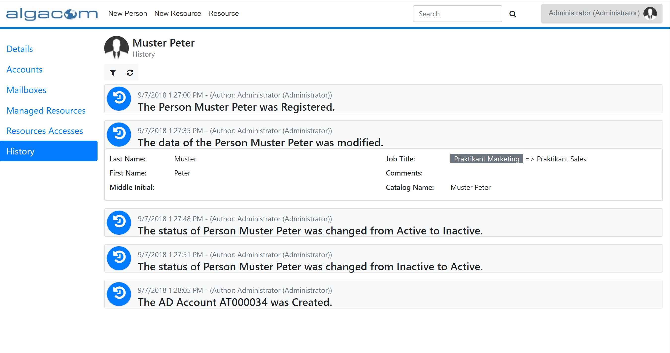

The aMIRA history view provides filtering capabilities making it easy to find specific changes (e.g. done by a specific person or in a certain time range).

### Transfers

Transfers can relate to the organization, to the geography or even both at the same time, e.g.:

* Employee moves from the marketing department to the sales department
* Employee is transferred from the Basel office to the Vienna office, but continues to work in the support team
* Employee is transferred from the Basel office to the Tucuman office and changes from engineering to development

In most cases, these changes are initiated through HR.

Policies may be set in aMIRA to initiate IAM-related actions upon certain moves, e.g.:

* Start re-attestation of all currently granted accesses to ensure no longer needed privileges are revoked
* Initiate transfer of account and/or mailbox data to another infrastructure that is closer to the employee's new working location

Refer to 4.4.4 for more information regarding access re-attestation.

### Temporary Leaves

A person can be on a temporary leave for many reasons, e.g.:

* Sabbatical
* Maternity
* …

Depending on the company policies, a person on leave may – or must not – continue to access the corporate network and services. To support these automations, aMIRA foresees a special status for persons (see section 3.2.1) that can be used to enforce these rules.

For example, aMIRA can be configured to automatically disable a person's accounts when the person status is set to "on leave".

### Re-Attestation

Companies need to have strict control over the persons working for them. Most importantly, to ensure that no person object – and possibly privileged accesses – are left active after a person has left the company.

For person objects linked to HR, this task is effectively delegated to HR. In other words, once HR executes a contract termination and the termination becomes effective (i.e. contract end date reached), the interface to aMIRA will properly update the person object (see section 3.4.6).

However, if person data management is done manually in aMIRA, a process must be in place to regularly enforce checking whether each person object is still needed – and if not, terminate it appropriately.

This process is called re-attestation and usually involves the person's line/company manager. Essentially, the manager is asked to confirm that the person being re-attested is still working for him/her. If this is not the case, the person object can either be terminated (if no longer needed) or transferred to another line manager.

Re-attestation is often used for external contractors or service providers, whose person objects might not be HR-linked.

### Terminations

Person objects must be properly terminated as soon as there is no valid contract anymore between the employee/contractor and the company. Termination ensures that associated accounts and PNRs are properly disabled end eventually deleted. Moreover, it ensures that any accesses are revoked.



Terminations can be initiated by HR (for HR-linked persons) or manually.

### Re-Hires

As long as a person objects is not purged, a re-hire usually means that a person object is already present in aMIRA and should therefore be reactivated.

This is a general IAM best practice and ensures proper traceability.

### Archiving

Person objects are usually set to status "inactive" when a person is no longer working for the company. Inactive persons are still easily visible in aMIRA – for easy audit purposes or to initiate re-hire operations.

Companies may decide to move person objects to status "deleted" to hide them in normal day-to-day operations. Note, however, that the records are still kept in the aMIRA data store to ensure traceability.

## Helpdesk Functions

Helpdesk functions as an essential aspect of user management. Being able to quickly and efficiently assist users being unable to logon is key for IT support organizations.

aMIRA allows for resetting an account's password and unlocking a locked account through its user interface. This functionality is available for all managed accounts on target systems that support this level of integration – such as (on-premises) Active Directory and Azure Active Directory.

Unlike other operations in aMIRA, these helpdesk functions mandate a "real-time" behavior: executing a password reset, for example, must happen immediately and give instant feedback about success or failure – allowing support agents to provide the newly set password to the user waiting on the phone.

This behavior is achieved through so called "**immediate operations**" in aMIRA provisioning. Essentially:

* The aMIRA UI submits these operations to the aMIRA provisioning and waits for them to be completed
* aMIRA provisioning executes these operations immediately, i.e. bypassing any available queue.

Helpdesk functions are accessed from the account details:

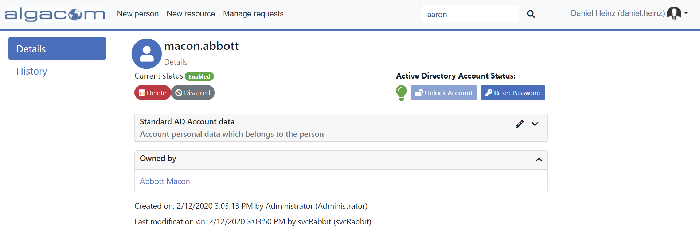

### Password Reset

For resetting a password, aMIRA can either suggest a password meeting complexity requirement, or the user can explicitly provide a new password:

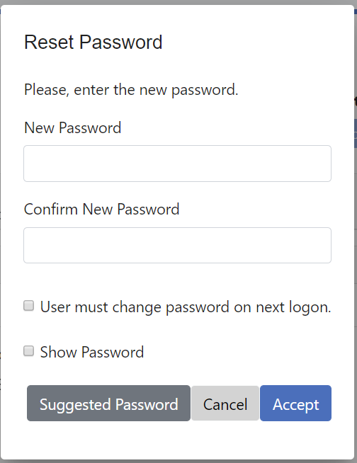

### Account Unlock

Unlocking an account is only enabled for accounts that are effectively locked out. So, for example, the account is not locked out in the following picture – indicated by the green bulb icon:

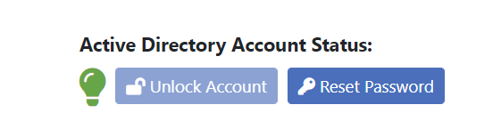

Hence, the account unlock button is not enabled.

# Resources and Access

## Data Model

### Definition

**Resources** are the principal objects managed in the aMIRA resource and access management module. Unlike the PNRs managed along with persons and accounts, these resources are shared ones and therefore non-personal and typically used by multiple persons (e.g. a document library used by a project team).

All resources have so called resource managers, who are responsible to maintain the resource properties as well as to grant/revoke access to the resources. By default, aMIRA distinguishes between the following resource managers:

* **Owner**: is the main responsible person for the resource
* **Deputy**: supports the owner in his/her responsibilities – a resource can have many deputies
* **Escalation contact**: is involved in case requests remain pending for an extended period of time

**Access** to resources is defined using so called Access Types (e.g. "read/write" and "read-only" for file shares). The type definition of a resource also defines the types of access that it supports.

The basic data model is shown in the following diagram:



The term "beneficiaries" is used to denote persons having access to resources (i.e. who can benefit from the resource by using it).

In the example above, the shared network resource has an owner (person 1), two deputies (persons 2 and 3) and an escalation contact (person 4). It grants access to three persons (A, B and C) with defined access types (X, Y and Z).

Note: in scenarios where aMIRA does not manage persons and accounts (i.e. for customers only utilizing the resource and access management functionalities), linked objects (such as owner, deputies, beneficiaries) would usually be an external account (usually an AD account in the target system).

### Default Types

Type configurations can be used to tailor the resources and accesses managed in aMIRA to the actual needs of the company. aMIRA provides several default types out of the box, which can be used as a starting point.

The defaults cover scenarios like:

* Exchange resources (shared mailboxes, room/equipment mailboxes, distribution lists, …)
* Office 365 resources (Exchange resources, Teams, …)
* File server resources
* …

## Object Status and Lifecycle

As with personal network resources, also the shared network resources have a defined status in aMIRA. The status determines if and how these resources behave and how they can be used in the overall system.

For example, an "enabled" resource can be fully managed and accessed by the beneficiaries, while a "deleted" resource is no longer available for use.

The main difference to PNRs is that the status of a shared network resource does not depend on the status of its resource managers (e.g. owner, deputies). In other words, the resource will continue to exist as an "enabled" resource even when all its resource managers have left the company. Obviously, the resource will then be orphaned and require a new owner – but it will still be available to the beneficiaries.

### Status Values

#### Shared Network Resources

The status values for **shared network resources** are the same as for personal network resources:



However, the definitions slightly differ:

* **Enabled**: the object is actively in use and available to users for new access request
* **Disabled**: the object is actively in use and can be fully managed by the resource managers, but it is not available to users for new access requests
* **Deleted**: the object is no longer needed and can therefore be disposed of; when entering this status, access for existing beneficiaries is usually revoked immediately and a timer set to control delayed disposal of the resource – thus giving a "grace period" to recover from accidental deletions
* **Purged**: the object's disposal grace period is over and hence the object can effectively be removed from the target environment. Recovery is no longer possible. Although the object remains in aMIRA, it is no longer tracked/managed.

aMIRA itself is target system agnostic and therefore provides a two-step deletion process with a grace period in which a deleted object can usually be recovered without loss of data and/or functionality.

Depending on the capabilities of the actual target system, this may or may not be possible – or offer additional possibilities, that would then require some alignment within the model used in aMIRA.

Important: a deleted object can only be recovered (e.g. changed back to enabled) *without* any data and/or functionality loss *during* the grace period. Once the grace period is over, the object's status is aMIRA changes to "Purged" and the object is removed from the target environment (e.g. Filer, SharePoint, …).

#### Accesses

The status values for accesses are as follows:



Definition:

* **Active**: newly granted accesses are usually active – meaning the beneficiary can immediately access the resource according to the type of access (e.g. read-only)
* **Future**: accesses can also be granted for the future, i.e. access is not yet possible – but will eventually be enabled (transition to status "active" based on time)
* **Revoked**: access has been removed either explicitly (e.g. by the owner of the resource) or implicitly because of the resource being set to deleted; the beneficiary can no longer access the resource
* **Deleted**: access is no longer valid/possible as the beneficiary has been deleted (e.g. person has left the company)

Important:

* Revoked and deleted accesses are never re-granted. Instead, a new access is granted (e.g. in case a deleted resource is re-enabled)
* A transition to status revoked implies a provisioning action, whereas a transition to status deleted does not.

### Status Value Dependencies

The status of accesses depends on the status of the resources they are associated with. The dependencies are shown in the following table:

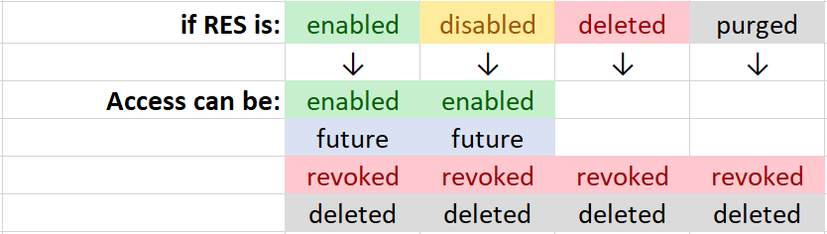

For example, a deleted resource cannot have active accesses.

### Automatic Status Transitions

Changes applied to the status of shared network resources can have an impact on the status of accesses defined on that resource. A typical example would be revocation of accesses to resources marked as deleted.

The following table shows how the resource status "drives" the status of accesses:

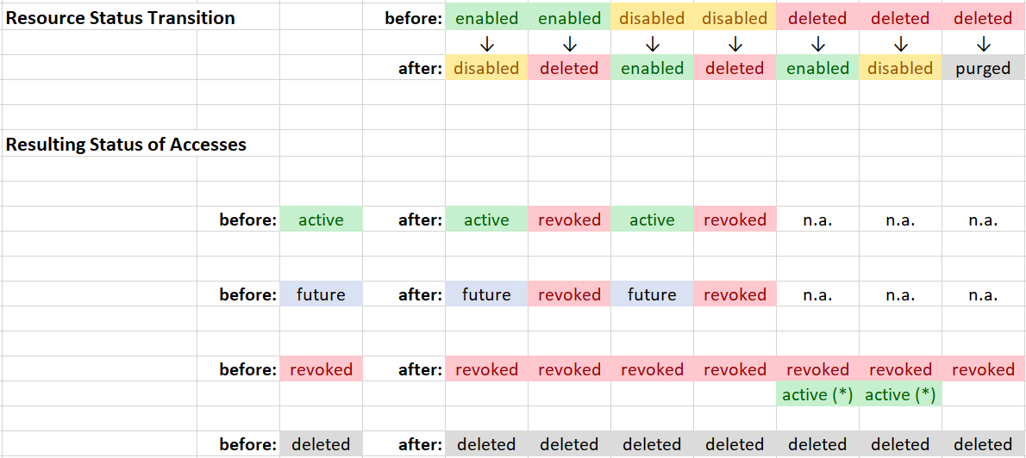

(*) = when a resource is undeleted, accesses that were revoked as part of the resource deletion are re-granted

For example:

* When a resource is set to "deleted", aMIRA will revoke all active and future accesses
* When a deleted resource is re-enabled, aMIRA will re-grant accesses (active or future) that had been revoked implicitly as part of the resource deletion. Note that these are newly granted accesses, i.e. existing revoked accesses are never re-activated.
* Resource status changes between enabled and disabled have no impact on accesses

## Default Lifecycle

aMIRA provides a predefined lifecycle for managing shared network resources and accesses. Refer to section 3.3 for information about the involved actors and roles.

### Shared Resources

The following table defines the default behavior of aMIRA. The lifecycle can be adapted to specific needs.

| **ID** | **Lifecycle Event** | **Trigger** | **Definition** | **Provisioning and Notifications** | **Cascading / Other Events** |
| --- | --- | --- | --- | --- | --- |
| R1 | Resource Requested | actor | A new resource has been requested | Notify OTO |  |
| R2 | Resource Request 1st Reminder | time | R1 Request has been pending for 2 days (configurable) | Notify OTO and REQ |  |
| R3 | Resource Request 2nd Reminder (Escalation) | time | R1 Request has been pending for 5 days (configurable) | Notify DSK and REQ |  |
| R4 | Resource Request Commented | actor | A comment has been added to a R1 request | Notify REQ and OTO  Notify DSK (if already escalated) |  |
| R5 | Resource Request Approved | actor | A request for a new resource has been approved | Notify REQ  Notify DSK (if already escalated) | Triggers R8 |
| R6 | Resource Request Denied | actor | A request for a new resource has been rejected | Notify REQ  Notify DSK (if already escalated) |  |
| R7 | Resource Request Cancelled | actor | A request for a new resource has been cancelled | Notify OTO  Notify DSK (if already escalated) |  |
| R8 | Resource Created | actor  INT  R5 | A new resource object has been created | Provision new resource to target system |  |
| R9 | Resource Data Changed | actor  INT | Data for an existing resource has been changed (except for status changes) | Provision object changes to target system |  |
| R10 | Resource Status E→X | actor  INT | Resource's status changed from enabled to disabled | None |  |
| R11 | Resource Status E→D | actor  INT | Resource's status changed from enabled to deleted | Revoke accesses  Start 30 days grace period (configurable)  Notify RMG  Cancel pending attestation (if any) | Triggers X9,  Triggers R16 once grace period is over |
| R12 | Resource Status X→E | actor  INT | Resource's status changed from disabled to enabled | None |  |
| R13 | Resource Status X→D | actor  INT | Resource's status changed from disabled to deleted | Revoke accesses  Start 30 days grace period (configurable)  Notify RMG  Cancel pending attestation (if any) | Triggers X9,  Triggers R16 once grace period is over |
| R14 | Resource Status D→E | actor  INT | Resource's status changed from deleted to enabled | Grant accesses revoked when resource was set to deleted,  stop grace period | Triggers X8 |
| R15 | Resource Status D→X | actor  INT | Resource's status changed from deleted to disabled | Grant accesses revoked when resource was set to deleted,  stop grace period | Triggers X8 |
| R16 | Resource Status D→P | actor  INT  time | Resource's status changed from deleted to purged | Deprovision resource from target systems |  |
| R17 | Resource Attestation Started | actor  INT  time | Request for attestation of resource has been started (only for enabled and disabled resources) | Notify RMG |  |
| R18 | Resource Attestation 1st Reminder | time | Resource attestation request has been pending for 30 days (configurable) | Remind RMG |  |
| R19 | Resource Attestation 2nd Reminder (Escalation) | time | Resource attestation request has been pending for 60 days (configurable) | Notify DSK and RMG |  |
| R20 | Resource Attested | actor | Attestation of resource has been provided | Notify RMG  Notify "initiator" (if not time and INT) |  |
| R21 | Resource Attestation Failed | time | Resource not attested within defined time period (90 days, configurable) | Notify RMG and OTO  Notify "initiator" (if not time and INT) | Triggers R11 or R13 |
| R22 | Resource Onboarded | actor  INT | A new resource object has been created for an existing resource | none | Optionally Triggers X13 |
| R23 | Resource Owner Changed | actor  INT | Resource owner has been changed | Notify new and old OWN |  |
| R24 | Resource Owner Invalid  (i.e. no longer active) | n.a. | Resource owner is no longer active | Notify DEP and DSK |  |
| R25 | Resource Deputy Added | actor  INT | A new resource deputy has been added | Notify added DEP |  |
| R26 | Resource Deputy Removed | actor  INT | An existing resource deputy has been removed | Notify removed DEP |  |
| R27 | Not Enough Valid Deputies Anymore | actor  INT | The number of active deputies is below the number of required deputies | Notify OWN and DSK |  |
| R28 | Resource Escalation Contact Changed | actor  INT | Resource escalation contact has been changed | none |  |
| R29 | Resource Escalation Contact Invalid (i.e. no longer active) | actor  INT | The resource escalation contact is no longer active | Notify OWN and DSK |  |
| R30 | Resource expired | time | The resource expiration date is reached | Notify OWN and DSK  Delete the resource | Triggers R11 |
|  |  |  |  |  |  |

Status values: **E** = enabled / **X** = disabled / **D** = deleted / **P** = purged

Note: an attestation of individual resources is not available; implementations can use regular attestation instead

### Accesses

The following table defines the default behavior of aMIRA. The lifecycle can be adapted to specific needs.

| **ID** | **Lifecycle Event** | **Trigger** | **Definition** | **Provisioning and Notifications** | **Cascading / Other Events** |
| --- | --- | --- | --- | --- | --- |
| X1 | Access Requested | actor | A new access has been requested | Notify OWN and DEP |  |
| X2 | Access Request 1st Reminder | time | Request has been pending for 2 days (configurable) | Notify OWN, DEP and REQ |  |
| X3 | Access Request 2nd Reminder (Escalation) | time | Request has been pending for 5 days (configurable) | Notify ESC and REQ |  |
| X4 | Access Request Commented | actor | A comment has been added to a request | Notify REQ, OWN and DEP  Notify ESC (if already escalated) |  |
| X5 | Access Request Approved | actor | A request for a new resource has been approved | Notify REQ  Notify ESC (if already escalated) | Triggers X8 |
| X6 | Access Request Rejected | actor | A request for a new resource has been rejected | Notify REQ  Notify ESC (if already escalated) |  |
| X7 | Access Request Cancelled | actor | A request for a new resource has been cancelled | Notify OWN and DEP  Notify ESC (if already escalated) |  |
| X8 | Access Granted | actor  INT | A new access has been granted | Grant access in target system  Notify BEN |  |
| X9 | Access Revoked | actor  INT | An existing access has been revoked | Revoke access in target system  Notify BEN |  |
| X10 | Future or Temporary Access Becomes Valid | time | A future/temporary access is now valid | Grant access in target system  Notify BEN |  |
| X11 | Temporary Access Expired | time | A temporary access is now expired | Revoke access in target system  Notify BEN |  |
| X12 | Beneficiary Invalid | N/A | Beneficiary is no longer active or existing (e.g. Person not active/on leave or account deleted from AD) | Flag access as deleted |  |
| X13 | Access Onboarded | actor  INT | Existing accesses have been imported | none |  |
| X14 | Access Attestation Started | actor  INT  time | Request for attestation of a single access has been started | Notify RMG |  |
| X15 | Access Attestation 1st Reminder | time | Access attestation request has been pending for 30 days (configurable) | Notify RMG |  |
| X16 | Access Attestation 2nd Reminder (Escalation) | time | Access attestation request has been pending for 60 days (configurable) | Notify DSK and RMG |  |
| X17 | Access Attested | actor | Attestation of access has been provided | Notify RMG  Notify "initiator" (if not time and INT) |  |
| X18 | Access Attestation Failed | time | Access not attested within defined time period (90 days, configurable) | Notify RMG  Notify "initiator" (if not time and INT) | Triggers X9 |
|  |  |  |  |  |  |

NOTE: single access attestation (X14 – X18) is currently planned (i.e. not available yet)

## Business Processes and Use Cases

### Resource Creation

Resources are usually created out of a specific need, e.g.:

* A newly appointed project manager needs a document repository for the project
* A new meeting room has been created and needs to be made available for booking through Outlook

aMIRA allows submitting requests for new resources of the desired type that are then verified and (hopefully) approved by so called resource type owners. During the request process, the user must provide the following information:

* A name and description for the new resource
* The name of the designated resource owner and deputies (plus an escalation contact)
* The names of persons who shall be granted access right after the creation of the new resource
* Any resource type specific information (e.g. number of seats for a meeting room, …)

The following picture shows a typical sequence in the order resource wizard:



Once submitted, the request is queued for the resource type owner for review and approval.

### Access Management

Once a resource has been created, it can further be managed by the resource managers (usually, the owner and his/her deputies) in aMIRA, e.g.:

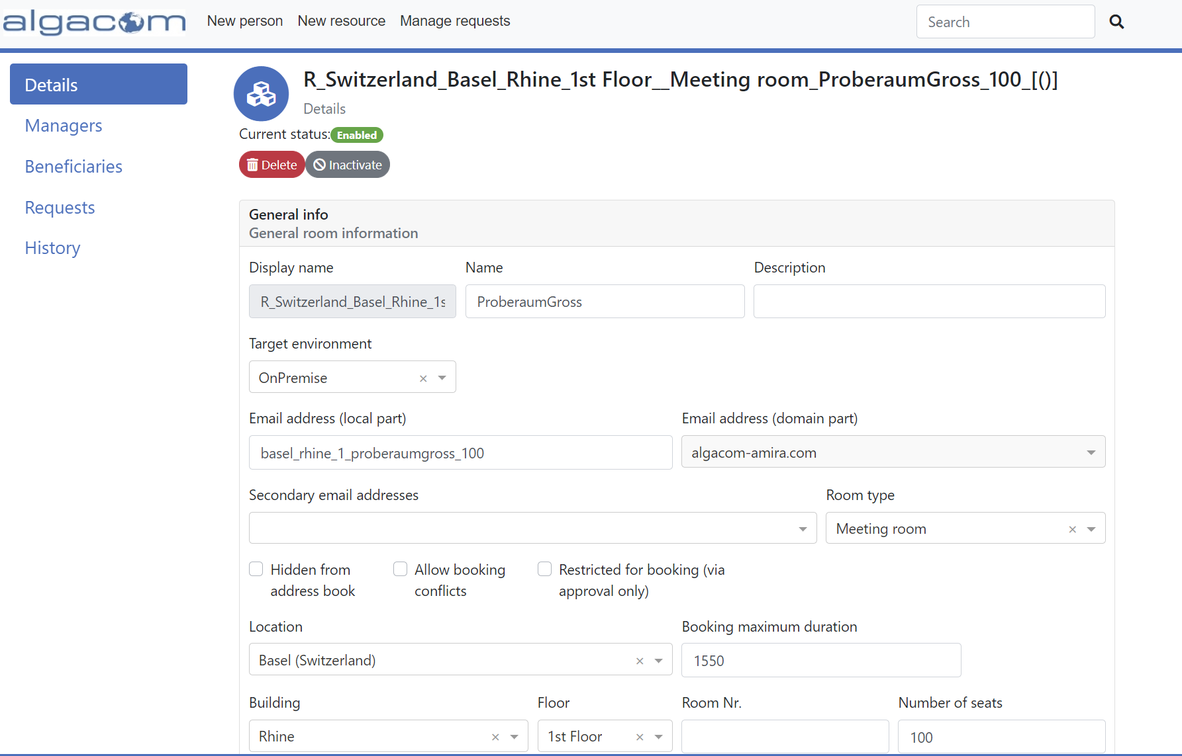

Resource managers can now view and change the details of their resources. Moreover, they can use aMIRA to easily grant and revoke access to their resources.

### Access Request and Approval Workflows

Users can access the aMIRA UI to search and request access to resources they need.

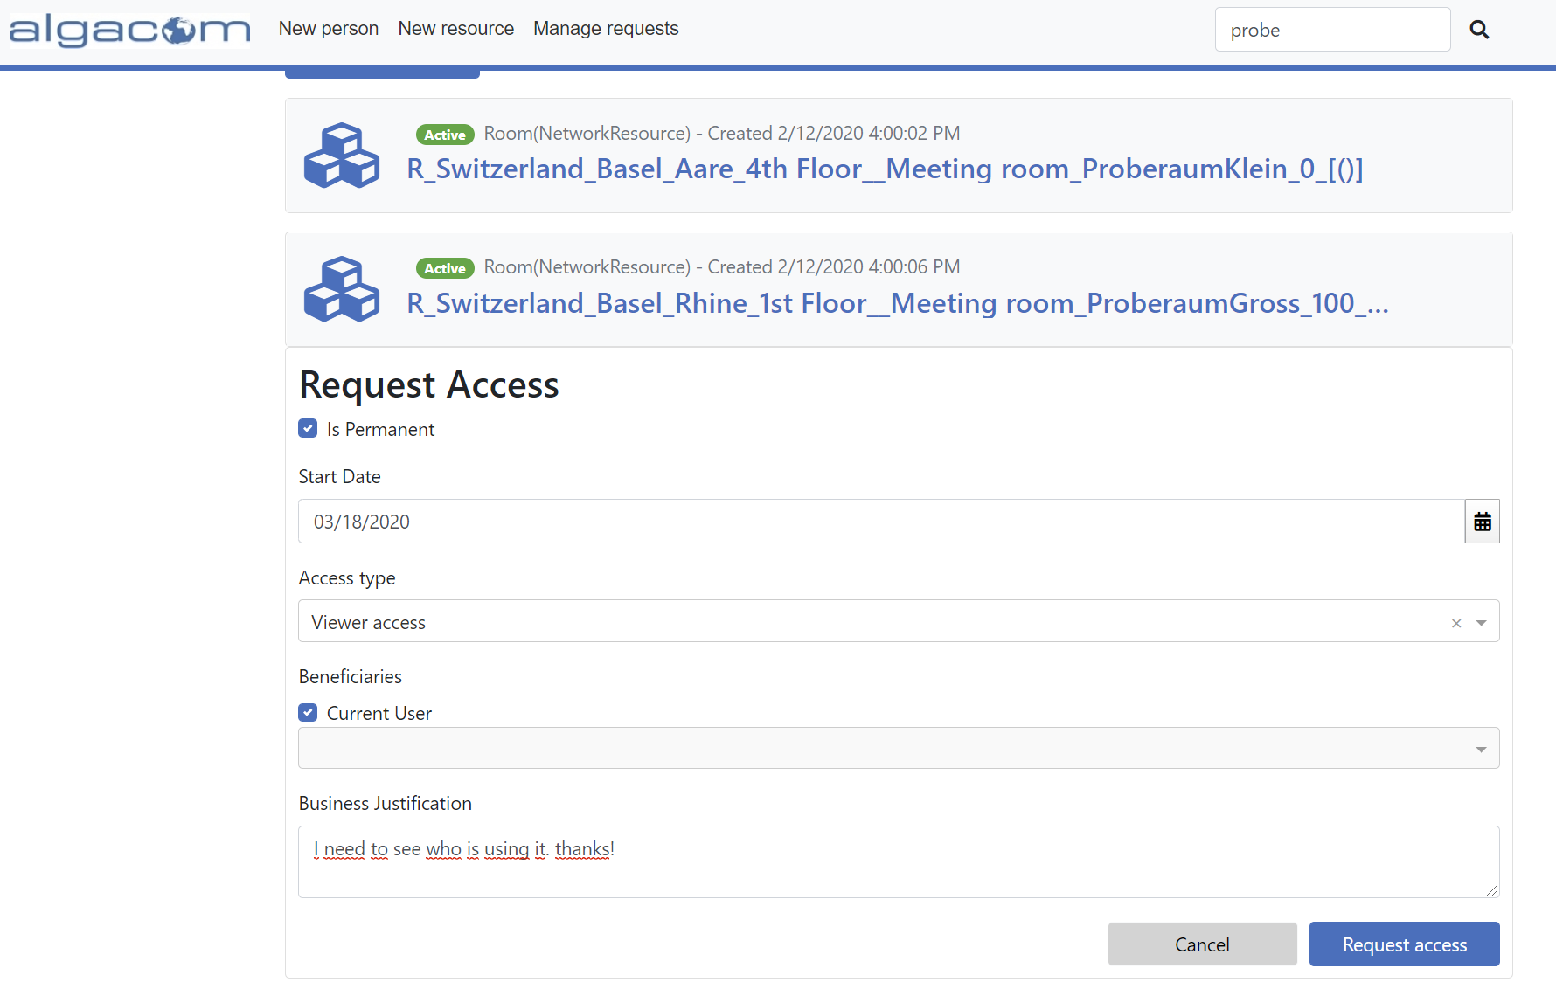

Access requests can be submitted for the logged-on user or for another person (i.e. on-behalf). Additionally, a single access request can include multiple beneficiaries.

Submission of the access request initiates an approval workflow. aMIRA supports the following approval workflows out-of-the-box:

* Approval by the line manager
* Approval by a resource manager
* Approval by the line manager – followed by approval by a resource manager
* Auto-Approval

Custom workflows can be built according to the company's business processes.

Pending requests are listed for processing:

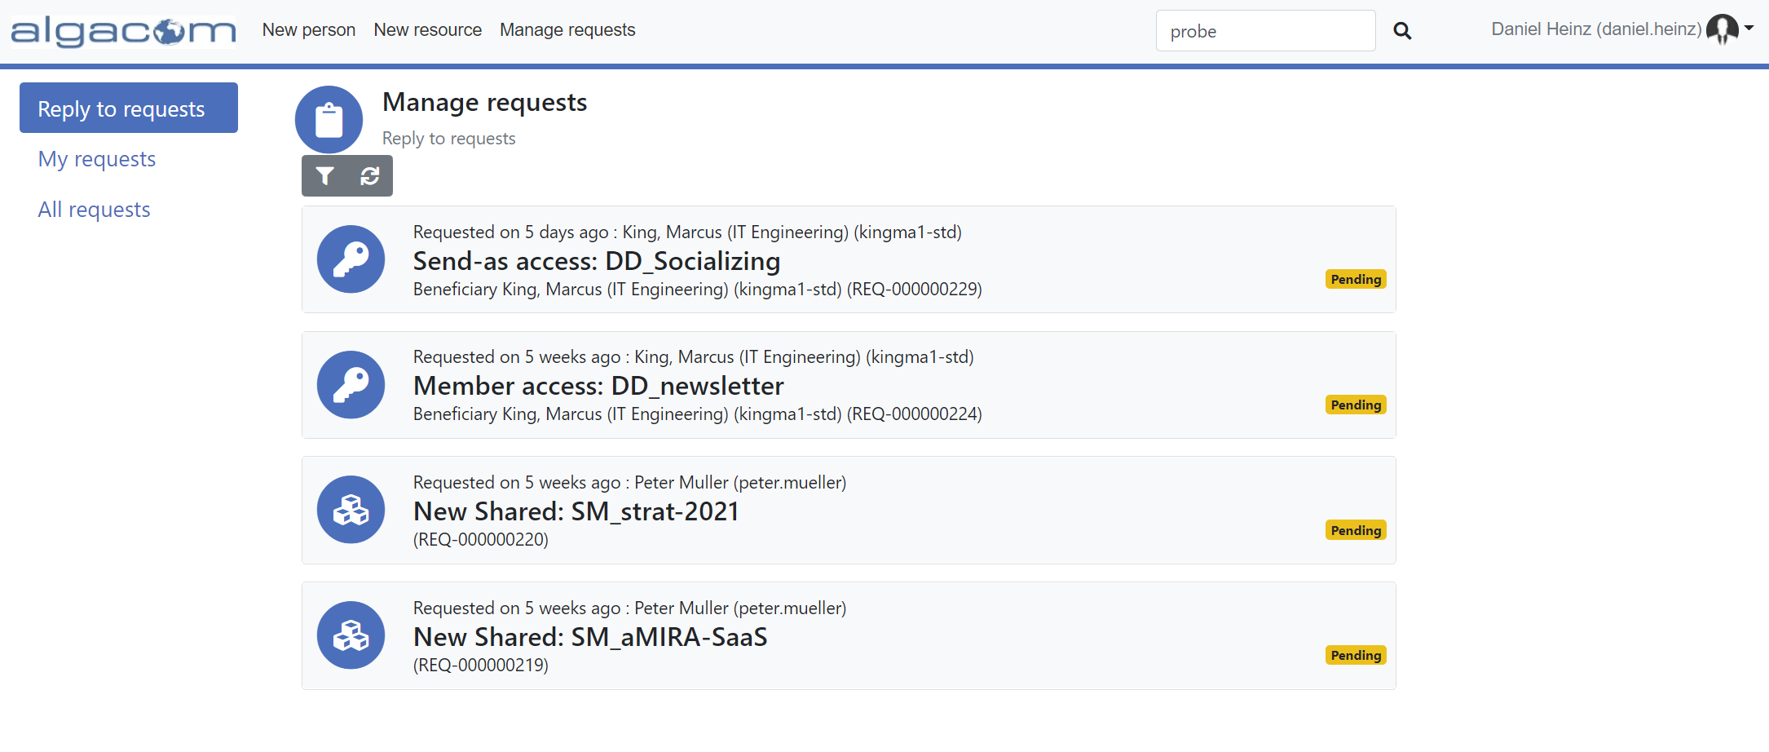

Access requests with single beneficiaries can be approved/rejected right from the list. In case of multiple beneficiaries, the request must be opened to access the complete list.

The following diagram illustrates a complete access request workflow:



All interactions are done using the aMIRA web UI.

### Resource and Access Re-Attestation

Unlike personal network resources (PNRs), shared network resources are not strictly associated with a person and therefore do not need to be terminated when the owner leaves the company. To prevent having "orphaned" resources as well as an accumulation of no longer needed resources, proper lifecycle management for resources is a must.

This is where resource re-attestation comes into play. This process is usually triggered automatically (e.g. every 6 months) and is directed to the resource managers (owner and deputies) asking for:

* Confirmation that the resource is still needed
* Confirmation that the resource managers are still valid – or asking for appropriate corrections
* Review of – and possibly corrections to – the list of current beneficiaries having access to the resource

Resources that are not re-attested in time can automatically be disabled or even deleted by aMIRA.

### Escalations

Requests that are not processed in time (e.g. within a configurable number of days after submission) must be escalated. aMIRA offers multi-level escalation mechanisms – for example:

1. After 3 days, re-notify the resource managers
2. After 5 days, notify the escalation contact of the resource
3. After 8 days, notify the Service Desk

The notified person will then have the right to view and process the request in aMIRA.

### Resource Decommissioning

A resource that is no longer needed must be decommissioned. This is usually triggered by the resource owner using the aMIRA web UI. Alternatively, it can be automatically initiated as a result of a failed resource re-attestation (i.e. resource managers didn't respond to the request).

aMIRA uses a "safe decommissioning" approach, which ensures that accidental deletions can be reverted quickly. Here is the resource decommissioning sequence:

* When the deletion is triggered, access to the resource is revoked immediately – thus preventing users from working with the resource. However, information about all active beneficiaries at the time of the resource deletion is kept in aMIRA to enable a potential undelete.
* Additionally, the resource is no longer visible in the aMIRA by default, so users will not be able to find it for submitting access requests.
* Nevertheless, the resource is kept in place for a configurable grace period. During this time, it can be undeleted, and all former active accesses are immediately and automatically re-granted.
* Once the grace period is over, aMIRA will deprovision the resource – effectively deleting the objects in the target environment.

Alternatively, companies can decide to immediately delete resources. However, safety mechanisms are still highly recommended – for example allowing the deletion of document repositories only if they are empty (i.e. owner must ensure proper archiving of data before being allowed to delete).

# Collections

*NOTE: collections are foreseen for a later release of aMIRA.*

## Data Model

### Definition

aMIRA **collections** are used to logically group objects. This per se doesn't yet imply a semantic to the collection – instead, collections can be used to model quite a lot of different business scenarios, as will be illustrated in section 0. Objects can be associated with more than one collection at a time.

Like shared resources, collections have an **owner**, any number of **deputies** and an **escalation contact**. These principals are primarily involved in the lifecycle and processes around the collections. Moreover, collections can have persons, accounts and resources associated with them.

The general data model for collections is shown in the following diagram:



In this example, the collection…

* … has persons associated as members,
* … three associated resources – where two of them inherit owner, deputies and escalation contact from the collection,
* … two associated accounts,
* … is related to a parent collection.

These mechanisms will be used to model a variety of business cases.

### Default Types

Type configurations can be used to tailor the collections managed in aMIRA to the actual needs of the company. aMIRA provides several default types out of the box, which can be used as a starting point.

The defaults cover scenarios like:

* Organizations
* Project teams
* IT services
* …

## Object Status and Lifecycle

Collections have their own status value, which can be related to the objects contained in the collection. Status propagation and/or status aggregation can be used on collections, e.g.:

* Disabling a collection could automatically disable all objects it contains
* The status of the collection could be a aggregation of the status of the contained objects

## Default Lifecycle

Like other objects managed by aMIRA, also collection have a defined lifecycle. It is similar to the one of shared network resources.

## Business Processes and Use Cases

Collections provide a very flexible mechanism to model and manage a variety of business scenarios. The following sections provide a few examples – focusing on individual aspects.

However, the real power of collections comes from the combination of two or more of these scenarios, as shown in an example in section 5.4.7.

### Organizations

Probably the most obvious usage of collections is to model the organization of a company. This includes the permanent line organization (e.g. divisions, departments, teams, …) as well as temporary organizations (e.g. project teams).

Associates are assigned to a collection – or to several collections – according to their affiliation in the company:



The manager of an organization is set as the owner of the collection and deputies can be managed as needed. Both can manage the association of team members to their team collection.

Automatic assignment/de-assignment of members (e.g. based on person properties) is supported by business policy automation (see section 6).

Using the parent-relation it is also possible to model organizational hierarchies:



### Access Role Profile

Collections can be used to define generic access role profiles that cover a set of resource access permissions, such as all accesses that a person requires based on a specific role in the organization.

Essentially, collections represent the roles in the organization and are used as the beneficiaries of network resources. Once assigned to such a collection, persons get the whole set of access permissions indirectly:



In this example, the collection "Finance Controller Role" encompasses all resource accesses that a person acting as a controller must have. The owner of the collection can now assign persons to her role and hence grant access to the desired resources.

Automatic assignment/de-assignment of members (e.g. based on person properties) is supported by business policy automation (see section 6).

### Non-Personal Objects

Quite often it is necessary to manage objects that are not directly "representing" a person, such as a helpdesk, an external institution that the company is doing business with, … In these scenarios, collections somehow play the role of non-personal (or generic) identities, which then can own the necessary resources.



In this example, the collection represents the Helpdesk with its shared mailbox, which grants access to the collection itself. In other words, persons associated with the collection – the helpdesk agents in this case – automatically get access to the shared mailbox.

### External Institutions and Service Providers

External institutions and services providers requiring access to the company's network can be modeled with collections quite elegantly.

In case of non-personal (generic) accounts, the collection represents e.g. the service provider and its associated persons, and acts as the owner of the account(s) at the same time:



In case the service provider's personnel is using personal accounts, the collection still represents the service provider and the associated persons:



In both scenarios, the owner of the collection is designated as the internal responsible for the relation of the service provider.

### Simplified Resource Management

For more centralized IT organizations, individual persons can be the owners of quite a lot of resources. Rather than managing this ownership individually, resources can be grouped using a collection and configured to inherit the resource manager associations (owner, deputies and escalation contact) from the collection:



As a nice side-effect, this also allows handing over the whole set of resources to a different owner in a single operation.

### Complex IT Services

In today's organizations, IT resources are usually managed as (complex and possibly abstract) IT services that encompass all building blocks. Collections can be used quite naturally to model IT services:



In this example, all building blocks of IT service "ABC" – such as shared folders, databases, shared/generic mailboxes, servers, application roles, cloud services, service/generic accounts … – are grouped into a collection that is assigned to the owner of the IT service.

### Putting it all together

The real power of collections becomes evident when putting several concepts together, as shown in the following example:



The **Corporate IT Department** is managed by head of Corp. IT and structured into **3 teams** – Wintel, Database and IAM. All teams have their own **staff members** and **team leads**, who use their own **personal accounts and mailboxes**.

The **IT Service "IAM"** has a defined **service owner** and consists of several building blocks: a **server**, a **database**, a **shared mailbox** (with related account), **application roles** and a **service account**. The service ownership is **inherited** down to the database, application role and shared mailbox resources. Only the server resource ownership is not inherited, but **specifically set** to someone from the Wintel team.

The software product for the IAM service is provided by an **IAM software vendor** that is coordinated by an **internal contact** and has its staff assigned explicitly

The involved teams as well as the IAM software vendor are **granted access** to the various resources of the IAM IT Service.

NOTE: for better readability, certain details haven been omitted (e.g. deputies, escalation contacts, …)

# Business Policies Validation and Automation

aMIRA offers the possibility to define policies for the validation and automation of tasks. For example, such policies can be used as follows:

* Foresee complex name generation rules (email addresses, unique userIDs, …)
* Validate – and possibly adapt – data that is entered by users
* Automatically create or update objects based on certain conditions
* …

aMIRA differentiates as follows:

* **Business Policy Validation**: logic that is executed **before** an object is created/updated
  + Somehow comparable to a pre-insert/update trigger for databases
* **Business Policy Automation**: logic that is executed **after** an object has been created/updated
  + Somehow comparable to a post-insert/update trigger for databases

Note that these mechanisms are used to address logic that is not covered by the capabilities of the property bags – namely:

* **Dynamic property bag validators**: used to validate a single property (e.g. format of a single value) or the whole property bag (e.g. start date not after end date)
* **Dynamic property bag services**: used to create default values (e.g. "service" that creates userIDs)

## Model

Simply speaking, **business policies validation/automation** denotes aMIRA's capability to act automatically upon certain events or based on time. Actions can include applying changes to objects, creation new objects or executing custom processes.

The basic model is shown in the following diagram:



Business policies validation/automation contains a set of **policy actions** that are activated by **triggers** and have an **effect**.

### Triggers

Business policy actions need a trigger to be executed/processed. In most cases, these triggers will be the events that occur within aMIRA as part of data maintenance – but also time (i.e. predefined schedule) can act as trigger.

### Policy Actions

Policy actions encompass the logic that must happen when certain events occur. This logic can be directed towards IAM itself, i.e. by executing aMIRA commands to create or update (the same of other) object(s). Or it can be outside IAM, i.e. send out a notification or invoke an external process.

Policy actions are implemented as script code handling predefined events and supporting:

* aMIRA commands
* sending notifications
* calling external processes (e.g. web services APIs)
* any other programmable logic

### Effects

Effects denote the actual result of a policy action from a business perspective. In other words, whatever shall happen automatically.

## Business Processes and Use Cases

Business policies automation can be used in a variety of occasions. The following chapters present some typical business scenarios.

### Business Role Assignments

Business roles are commonly modeled using aMIRA collections. While certain roles may need to be assigned and de-assigned explicitly (e.g. through an explicit approval step), other roles shall be assigned and de-assigned automatically by the system.

Quite often, this applies to basic business roles that are related to the functions that people working for a company have (e.g. financial controllers, marketing managers, …).

Assuming an adequate standardization of person data (e.g. input from HR systems), aMIRA can be instructed to manage role assignments automatically. For example, assignments could be based on the department property of the persons.

### Organizational Affiliations

The organizational affiliation can be handled in the same way as business roles assignments, i.e. using automation to (de-)assign persons to/from organizations modelled as collections.

### Access Attestation for Movers

Users need various accesses in order to perform their daily work. When they are transferred to another organization and/or location, most likely different accesses are required. This implicitly also means that current accesses may need to be revoked, as they are no longer needed.

Policies can be used to automatically trigger re-attestation of all current accesses – thus making sure that resource managers are notified about a person being transferred and can revoke any unneeded accesses to their resources.

### Data Maintenance and Provisioning Automation

One of the most common usage of business policy automation is data maintenance. This can be applied to the object triggering the policy in the first place as well as to other objects.

Examples for policy actions affecting the object itself:

* Updating the display name of a person when firstname and/or lastname is changed
* Adding the former email address of a mailbox as an alias when the primary email address is changed

Examples of policy actions affecting other objects:

* Automatically adding a standard AD account and Exchange mailbox to a newly registered person
* Updating the primary email address of a mailbox when the owner's name is changed

Also, validation and data generation are covered – possibly also with the involvement of external systems:

* Support for external data validators, e.g. ensure uniqueness through an external system/process
* Support for external data generators, e.g. create a uniqueID, set preferred names based on names from HR, …
* Checking for – and enforcing – segregation of duties criteria

# Security Model

Users need to authenticate to aMIRA in order to access its data and perform data management tasks. This applies equally to the web GUI and to the web services APIs.

Once the user is authenticated, the authorization service of aMIRA determines what he or she is allowed to do. Essentially, the aMIRA precisely defines **who** can do **what** and **where**.

The mechanisms for AuthN and AuthZ depend on the deployment method chosen for aMIRA.

## Authentication Model

On-premises deployments of aMIRA rely on Active Directory and the Integrated Windows Authentication (IWA) functionality provided by the IIS hosting the aMIRA web site.

In other words, the server(s) hosting aMIRA must be joined to the on-premises AD and users wanting to access aMIRA must be logged on using a valid account (same AD or a trusted AD forest).

Alternatively, users can access aMIRA using their Azure AD credentials.

## Authorization Model

aMIRA provides a flexible security model allowing to precisely specify **who** can do **what** and **where**:

* Who = Principal or Collection
* What = Command (or set of commands)
* Where = Scope where the command(s) can be applied

The authorization model applies to all operations done – regardless of the UI (e.g. web GUI, web service API). Definitions can be very granular, e.g. down to individual properties of the data types, and also depend on the data itself.

## Default Role Model

aMIRA provides a default role model that can be extended based on specific needs.

|  |  |  |  |
| --- | --- | --- | --- |
| **Role** | **Assignment** | **Permissions** | **Comments** |
| Administrators | Explicit group |  | Group in on-prem AD or Azure AD; can be managed in aMIRA |
| ServiceDesk | Explicit group | Identity & Accounts   * Create and manage persons * Create and manage accounts * Create and manage mailboxes     Resources & Access   * Order new resources * Approve order resource requests * Manage all resources | Group in on-prem AD or Azure AD; can be managed in aMIRA |
| Person Manager | (implicit) | Identity & Accounts   * Edit non-locked properties of managed persons     Resources & Access: N/A | Persons being set as managers of other persons |
| Resource Manager | (implicit) | Identity & Accounts: N/A    Resources & Access   * Approve access requests for owned resources * Grant/revoke access to/from owned resources * Manage resource properties and status | Persons set as owners, deputies or escalation contacts of resources |
| Users | N/A | Identity & Accounts   * Search * Display all information * Edit own personal email address field     Resources & Access   * Search * Display all information * Request access * Manage own access (e.g. delete) | All authenticated users – but can be restricted |

# User Interfaces

aMIRA has two main user interfaces: a **graphical UI** for interactive user access and a **web services API** for programmatic access. Both user interfaces offer roughly the same level of functionality.

## Graphical User Interface

The aMIRA GUI is web-based and therefore doesn't require any client-side software installation. It can be accessed using any of the supported web browsers (note: other browsers may work but might not have been officially tested).

## Web Services API

aMIRA offers a REST web services API that can be accessed by technical processes, for example:

* Partner systems that either query or write data from/to aMIRA
* Administrators who need to perform bulk data changes
* …

Documentation of the API is available online from the application UI.

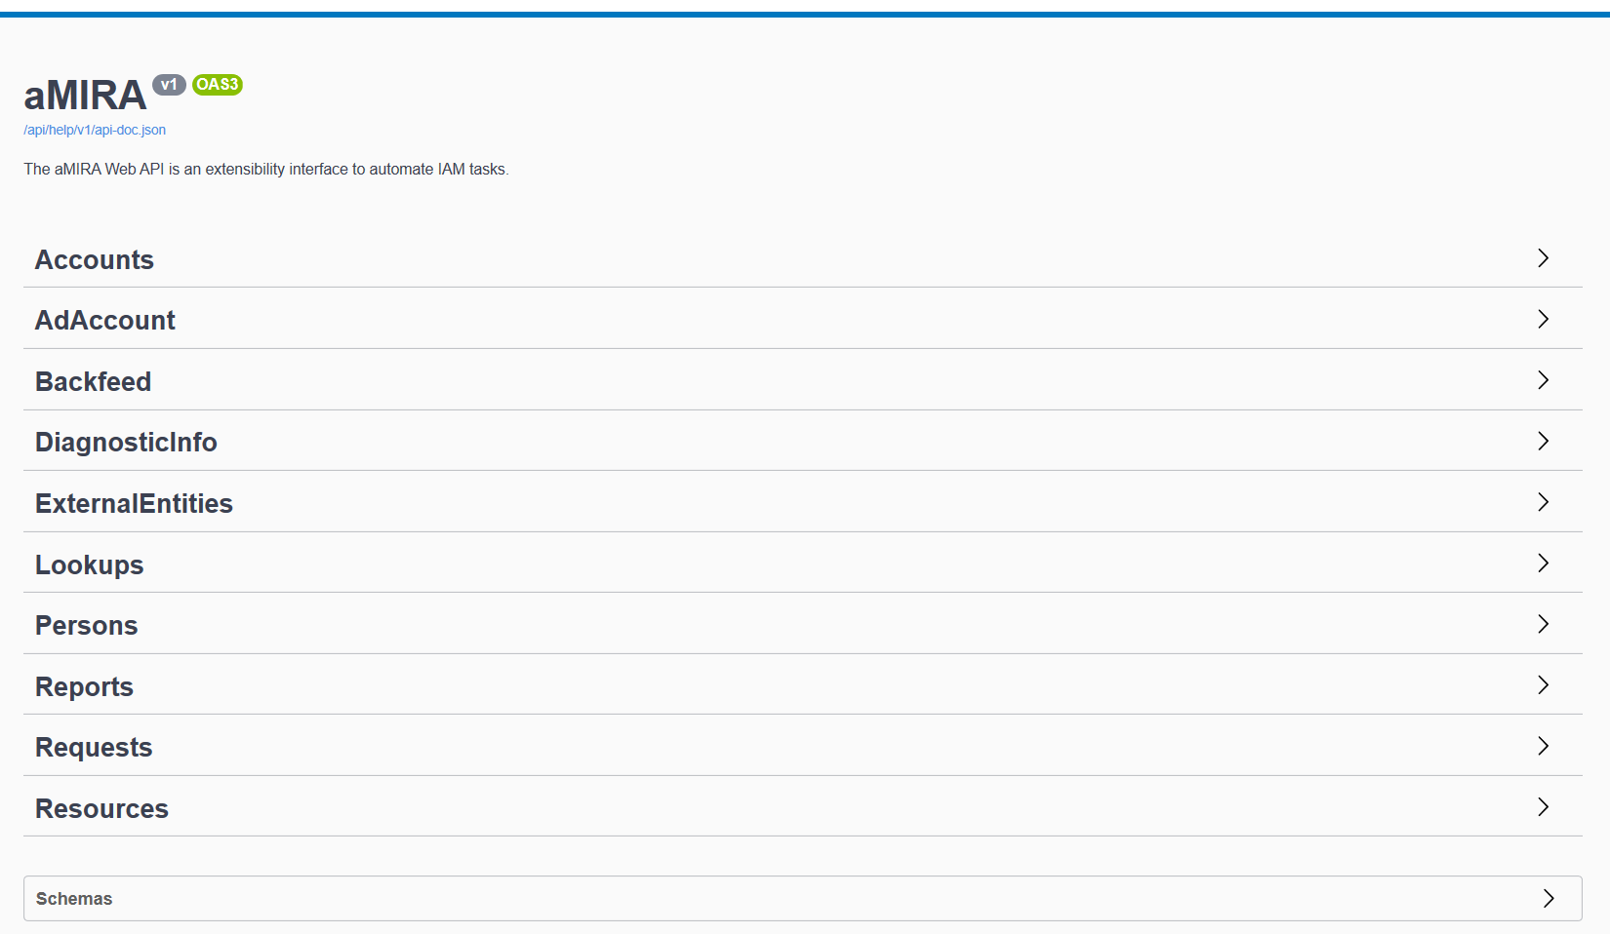

# Inbound Interfaces

IAM systems very often have inbound interfaces that are used to provide external data as well as to automate some of the lifecycle of this data. Here are some examples:

* A human resources (HR) system delivers personnel data to automate the initial creation, ongoing maintenance and final termination of digital identities in IAM – hence eliminating the need to manage this data manually in IAM.
* A finance system delivers information about the company's organizational structure (divisions, business units, …) and active cost centers essentially automating the maintenance of this structural lookup data in IAM.

The following sections will explain these two types of interfaces in more detail.

## Structural/Lookup Data Feeds

Structural/lookup data is often used to standardize the data model, ease data maintenance and increase data quality: rather than allowing users to enter free text data (e.g. a division code for a person), the user is forced to choose from a list of available values – thus enforcing a defined standard.

Some more examples:

* Locations
* Organizations
* Cost center codes
* Target system containers (OUs) for account provisioning
* Email domains
* …

## HR Feeds

HR can undoubtably be considered the most important data provider for IAM. It not only delivers personnel information (name, department, location, …) – and so prevents time consuming redundant data maintenance – but also **drives the lifecycle** of the "linked" digital identities in IAM.

It is in HR's own interest to properly register and delimit personnel data to support their key processes, such as hire, transfers, terminations and re-hires.

Consequently, IAM should generally trust HR as authoritative data source and align person identity management with the HR events. In other words, HR can (and should!) create digital identities for new hires, maintain them throughout their lifetime and finally terminate digital identities upon contract termination.

IAM person objects are "**linked**" when they are connected to a feeding HR system. In this case, all (or at least most) of the person object's properties are read-only, since they are owned by HR. IAM person objects are "**manual**" (manually maintained) if there is no feeding HR system for them. In this case, data maintenance is fully done in IAM.

A mixture is quite common, whereby HR delivers only a subset of the personnel records (e.g. employees) and other personnel must be maintained manually (e.g. contractors, service providers, …).

HR related events in scope include the following:

* New hires
* Re-hires
* Regular terminations
* Emergency exits
* International transfers
* Regular updates (incl. renames)
* Temporary leaves (e.g. sabbaticals)
* Status changes (e.g. internal ↔ external)

### Interface Implementation

In its simplest form, the aMIRA HR Feed interface operates on full HR data extracts that are processed as a whole and result in person objects being added and/or modified in aMIRA. The term "full HR data extract" needs some clarifications:

* Based on the IAM data model chosen for persons, only a (usually rather small) subset of the data fields managed in HR is relevant. For example, salary information and HR-specific data is not included, of course.
* However, all person records must be exported during every iteration with their current data (as valid of the time of the export – e.g. for changes that are delimited)

aMIRA supports any export format (XML, CSV, …) and will convert to a standardized format for processing as needed.

Alternatively, HR systems can also use the aMIRA web API to directly execute data maintenance operations in aMIRA. This would allow real-time processing between HR and IAM.

### HR-Driven Person Status Transitions

As stated above, HR will drive the lifecycle of person objects in aMIRA. To do so, aMIRA HR Feed will compare the HR data extract (TO-BE) with the current person data in aMIRA (AS-IS) and determine the changes that must be applied.

This is illustrated in the following status diagram:



The green boxes represent the HR feed actions that are determined during the data comparison process:

|  |  |  |
| --- | --- | --- |
| **HR Feed Action** | **Definition and related aMIRA Commands** | **Business Scenarios** |
| ADD | Creation of a new IAM person object, which will then be "linked" to HR.  aMIRA Command: Register Person | New hire |
| LINK | "Connecting" a HR data record to an existing manual IAM person object – essentially making it "linked" to HR. The previous status of the IAM person object can be anything but "purged" – and will be "active" once linked.  aMIRA Command: Update Person Custom Info | Re-hire  Delayed HR onboarding |
| UNLINK | "Disconnecting" an IAM person object from the HR data source – essentially making it "manual". The status of the IAM person will be kept "active".  aMIRA Command: Update Person Custom Info | Possibly done for international transfers – depending on HR systems |
| TERMINATE | "Disconnecting" an IAM person object from the HR data source because of an end of contract (or last working day) being reached. The IAM person will be set to "manual".  aMIRA Command: Update Person Custom Info | Termination (leaver) |
| DELETE | "Disconnecting" an IAM person object from the HR data source – essentially making it "manual". The status of the IAM person will be set to "deleted".  aMIRA Command: Update Person Custom Info | Special situations, e.g. "emergency terminations" or in case of a person's death |

The HR Feed is configurable in terms of

* the data model
* the validation rules (e.g. mandatory fields, lookups, …)
* criteria for linking to existing person objects

Automation can be used to further create or update related objects after HR-based changes, e.g.:

* automatically create an account and a mailbox for all newly hired persons
* …

## Target System Backfeeds

Target system backfeeds are used to bring data back into aMIRA for reference or processing. Usage examples include:

* Provide statistical and/or status information about the target system
* Utilize the AD "lastLogonTimestamp" property to automatically "age" accounts that haven't been used
* Revoke/remove accesses and/or capabilities that are not effectively used (e.g. automatically free Office 365 Licenses)

# Outbound Interfaces

Outbound interfaces are responsible to export data out of the IAM system. This can have several purposes:

* Most commonly, provisioning is used to transfer changes applied to the data in the IAM system to the connected target systems. For example, creating, maintaining and deleting accounts in Active Directory and mailboxes in Exchange. This usually happens immediately, i.e. whenever a change is applied in aMIRA.
* Another example is reporting, whereby data extracts are created according to specific criteria on a regular or ad-hoc basis.
* Finally, notifications transport specific information from aMIRA to the intended recipients – usually upon certain events or when processes are executed.

This chapter describes the main concepts for provisioning, notifications and reporting.

## Provisioning

aMIRA has its own provisioning engine called aMIRA Provisioning. It is tightly integrated with the aMIRA "core" application but can also be used separately for customer-specific applications.

Provisioning happens asynchronously based on a defined scheduler and is independent from the application of a change via aMIRA UI. The only difference are special tasks that must be executed synchronously, such as password resets and account unlocks.

### Architecture of aMIRA Provisioning

Provisioning uses the following concepts:

* **Operation**: structured parametrization
* **Action**: instruction how "things" are done in a target system
* **Job**: execution of a set of actions by the scheduler

Note: there is a 1-to-1 mapping between operations and actions.

These objects are visible and manageable through the aMIRA Provisioning UI.

Operations can be bundled in batches, e.g.:

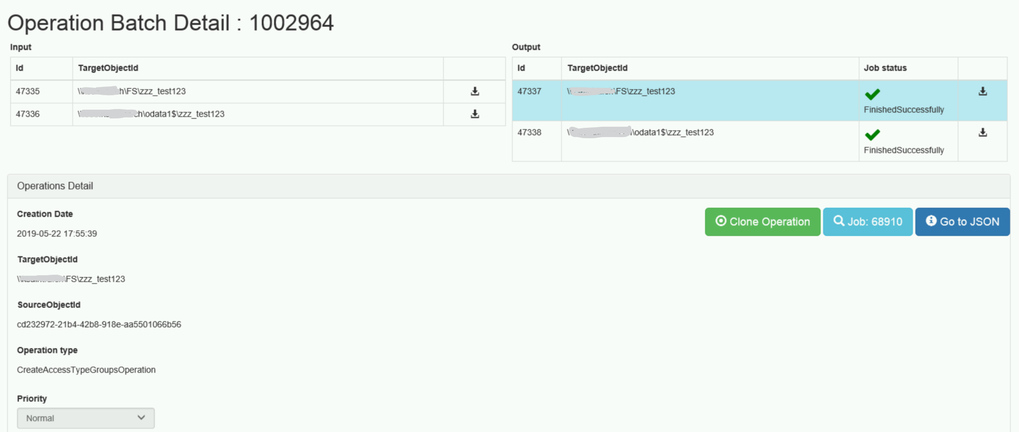

From the output operations, the user can navigate to the jobs that are the actual execution of the operations, e.g.:

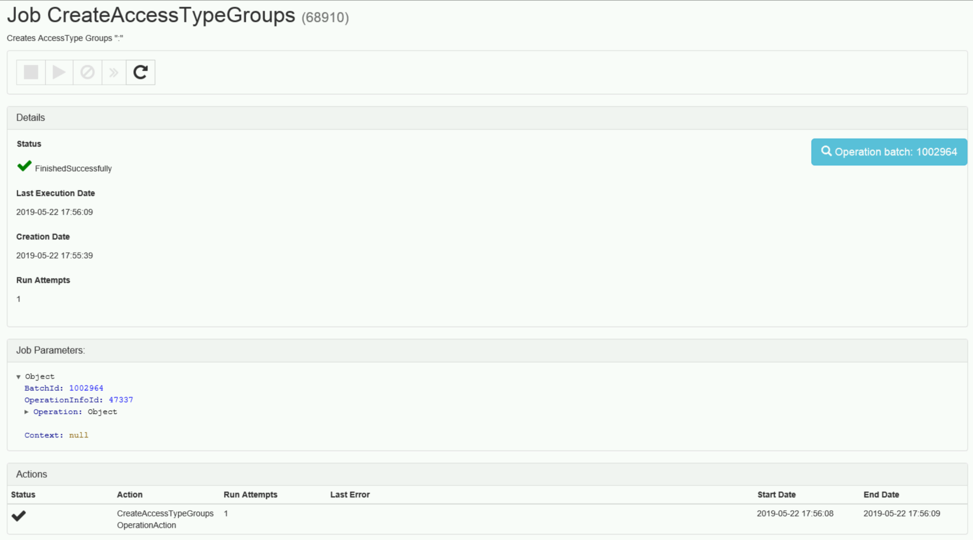

#### Operations View

The operations view only shows the output operations, e.g.:

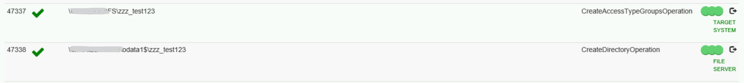

#### Job View

The job view lists all jobs, e.g.:





#### Components View

The components view displays the status of the single parts of the provisioning subsystem:

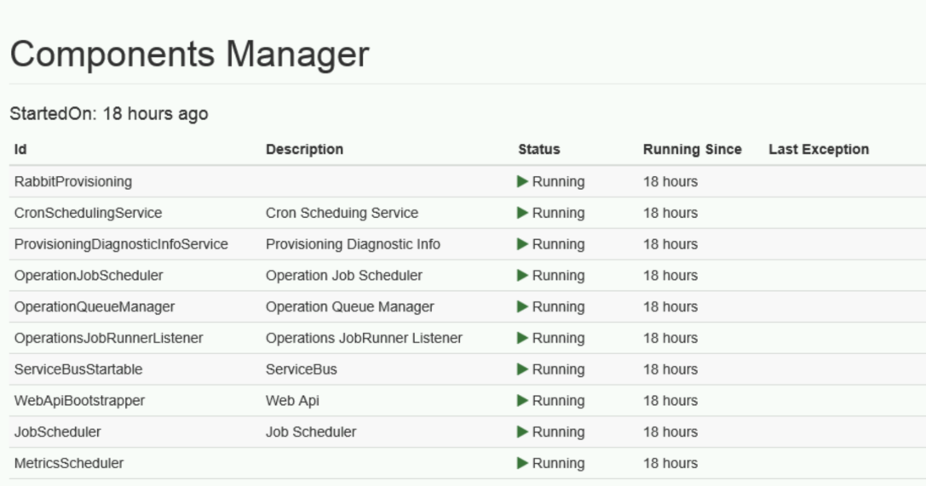

### Target Systems Supported by aMIRA Provisioning

aMIRA is target system agnostic. In other words, aMIRA can be configured to manage objects in virtually any target system – including completely custom-built business applications and IT systems.

However, aMIRA Provisioning natively supports several common target platforms that are present in many organizations:

| **Target System** | **Implementation Options** | **Supported Objects and Features** |
| --- | --- | --- |
| Active Directory | * On-premises AD * Azure AD | * User accounts * Contacts * Groups and memberships * Computer accounts |
| Exchange (on-premises) | * Single AD forest * Resource AD forest | * Mailbox users * Mail-enabled users * Distribution groups * Room and equipment mailboxes * Shared mailboxes |
| Skype for Business (on-premises) | * Single AD forest * Resource AD forest | * Enabling with different profiles (presence, chat, audio, video, desktop/app sharing) |
| SharePoint (on-premises) | N/A | * Site collections * Subsites * Libraries |
| Office 365 | * Cloud-only * Hybrid | * Exchange * Skype for Business * O365 Teams * O365 Groups * SharePoint * Applications managed using groups |
| File services | * Windows servers * Compatible storage devices | * Folders * Shares * Permissions * DFS links |

Additional target systems can be integrated with any of the following mechanisms offered by aMIRA Provisioning:

* Calling web services APIs
* Calling custom scripts (e.g. PowerShell)

## Notifications

aMIRA generates notifications based on events resulting from objects being created or modified as well as based on time. Refer to the default lifecycle definitions for examples (see sections 3.3 and 4.3).

All notifications are based on templates that utilize tags to automate the inclusion of context information. aMIRA provides a set of default templates that can be adapted to the specific needs (content, format, …).

## Reporting

aMIRA provides a set of reports that extract basic data from the repository. This data can then further be processed using external mechanisms.

Custom reports can be configured and added to the aMIRA UI for easy access.

# Glossary and Abbreviations

The following terms and abbreviations are used throughout this document:

|  |  |
| --- | --- |
| **Term or Abbreviation** | **Definition** |
| aMIRA | algacom Management of Identities, Resources and Accesses |
| Approval | Positive answer to a workflow kicked off due to a submitted request |
| AuthN | Authentication |
| AuthZ | Authorization |
| Beneficiary | User who is granted access to a resource |
| Collection | Set of objects to be placed into a common context |
| Command | User action that is submitted into aMIRA (e.g. via Web UI or web service) |
| Creation | Process of adding an entity to aMIRA that then usually ends up in provisioning one or multiple objects in target systems (e.g. an AD account, an Exchange mailbox or a file share). In other words, aMIRA really *creates* the object.  Cannot apply to persons, as persons (the human beings) are never "created" by aMIRA. |
| Data Model | Definition of object types and properties |
| Entities | The basic objects managed by aMIRA: persons, accounts, resources and collections |
| IAM | Identity and Access Management |
| Personal Network Resource | A managed resource that is forcedly bound to a person and can therefore not exist without that person (e.g. a personal mailbox) |
| PNR | see Personal Network Resource |
| Provisioning | Creation, maintenance and deletion of objects in target systems |
| Rejection | Negative answer to a workflow kicked off due to a submitted request |
| Shared Network Resource | A managed resource that is not strictly bound to a person (e.g. a document repository) |
| Types | Concrete definition of an entity (e.g. external collaborator, AD  account, …) |